Introduction
The following is the project description as provided from our sponsor, Mr. Rick Davids.
“The HOME system is a standalone, hybrid shelter that bridges emergency, ‘first responder’ and transitional shelters. Emergency shelter materials are tents, plastic sheets, tarps and other materials used immediately after housing is destroyed by natural or man-made disasters. Transitional shelters are more likely rigid frame structures built from cinder or mud block, wood, or sand bags as the base and lower structure with metal sheeting or plastic tarps as roofing material.

The HOME system is not connected to any electrical, power, water, sewer, septic, or other utility infrastructure. The intent is to design an independent structure that provides some of the life support and enhancement features such as adequate protection from the elements, personal storage, immediate access to water, and electrical power.”

We were granted the opportunity to work with the engineering students at Roger Williams University. After meeting with them and discussing how both groups wanted to move forward in a way that would utilize our different strengths, we decided that the water and electrical subsystems would be handled by the RWU team and the structural and overall design would be our responsibility. Each team met with Mr. Davids to discuss the design requirements for their respective systems. We were able to revise the original System Requirements Document that was provided to us by Mr. Davids to newly match our specific requirements for our assigned systems. A table of our system requirements can be seen in the Specifications Definition section of the report in Appendix A52-A60. The main requirements are adhering to UN guidelines for shelter, be self-sustaining, easy to assemble by two adults, have good structural strength, withstand the elements, and be long lasting.
The current shelters available provide a place to live for period of time until a new permanent residence can be established. The purpose of the HOME is to make that time comfortable for the occupants as well as providing utilities and security. IDPs and other people seeking shelter have usually lost everything in whatever form of event that caused them to lose their homes. Most will arrive at a camp or support center with only what they could carry on their person. Tents provided can only hold one or two people and provide very little protection from the elements, but can be ready to inhabit within a day. Transitional shelters provide much better protection from the elements but can take several weeks to a couple months to make ready. The HOME is able to provide four 95th percentile adults a place to live with solid protection from the elements. The HOME also provides self sustaining electrical power and water collection. Both are features that can currently only be found in transitional and permanent shelters.

Project Planning
The managerial tool implemented to keep a schedule was Microsoft Project. The switch from Google Docs Spreadsheets came about with the need to have a hard copy of the project plan for reference in the project binder and Microsoft Project allows for easy printing of the entire Gantt Chart and can also be found in Appendix A37-A38 of this report. The most major tasks performed were the testing and redesign phases, which saw some significant changes to the design of the HOME. The first step was to machine test samples for some of the tests out of the HDPE that was purchased to mimic the interface between the walls. While this was done, rapid prototyping of the model was also taking place in preparation for other tests, such as the test runs done in the wind tunnel and assembly. Finite Element Analysis was also done on the design during the testing phase and with all the gathered data, lead to the redesign process, the other major task performed in the past few months.
Meetings and contact were also made with people from different organizations that gave better insight into the nature of disaster relief. These people include the director of the Rhode Island Emergency Management Agency (RIEMA), David Smith, the Deputy Director of RI Red Cross Norm Menard, Colonel David Medeiros of the Army National Guard, who was helpful in providing information on ISO containers, and Joshua Manfredo, the assistant to the Chief of EMS division at URI. From a managerial standpoint, email correspondence and phone calls were used to organize and set up these meetings.

Cost Analysis
At the outset of the project, the desired price point for the HOME was $3000 for aspects of the product. In order to meet requirements, however, the materials alone for the structure exceed the desired cost by $1,052.78. The necessary components for the electrical subsystem are nearly half the original cost on their own at $1,453.27. There are also the manufacturing costs of paying the machinist that will weld some components to others to reduce cost as opposed to using injection molding as the manufacturing method. The breakdown of the cost of all the individual items is given in the following tables. An additional cost in making a rapid prototype model is included as well but not at the cost of the sponsor but to the department of Mechanical Engineering at URI.
Original Desired total cost: $3000
URI Team
Item (Item #) | Cost per Item | # | Total Cost
8’ X 4’ X ¼‘’ HDPE Sheet (9785T161 McMaster) | $114.23 | 25 | $2855.75
8’ X 4’ X 1’ HDPE Sheet (8619K119 McMaster) | $336.64 | 3 | $1009.92
6- ½ ’ X ½ ’’ HDPE Rod (8701K41 McMaster) | $5.78 | 6 | $34.71
1’’X 20’X.03’’Silicone Gel Gaskets (2750K21 McMaster) | $76.20 | 2 | $152.40
Total Material Cost |  |  | $4052.78
Table 1. Materials for one unit of HOME

Item | Cost Per Hour | # | Total Cost
Average Machinist Worker [4] | $17.77 | 12 | $213.24
Sharpetek Handheld Ultrasonic Plastic Welder | - | 1 | $2900.00
Total Cost |  |  | $3113.24
Table 2. Manufacturing Costs

Item | Cost Per Item | # | Total Cost
Medium Plastic Storage Cart | $21.99 | 2 | $43.98
Byer Alagash AL Cot | $39.99 | 3 | $119.97
Johnson & Johnson First Aid Kit | $4.99 | 1 | $4.99
Water Purification Tablets (50) | $4.95 | 1 | $4.95
34 Rubbermaid Tupperware Set | $19.99 | 1 | $19.99
Sterilite 4-Shelf Shelving Unit | $29.97 | 2 | $59.94
Cannon Microfleece Blanket (twin size) | $12.99 | 4 | $51.96
Colgate Max Fresh Full Head Soft 456 Toothbrush Value Pack, 4 ct | $7.97 | 1 | $7.97
Colgate Irish Spring Moisture Blast with Hyrdrobeads Deodorant Soap Bar, 4 oz , 8 ct | $3.88 | 1 | $3.88
Suave Professionals 2 In 1 Plus Shampoo + Conditioner, 32 fl oz | $2.94 | 1 | $2.94
Colgate Fluoride Cavity Protection Toothpaste, 2pk | $3.24 | 1 | $3.24
Total Cost |  |  | $318.82
Table 3. COTS (Commercial of the Shelf) Products
RWU Team
Item | Cost Per Item | # | Total Cost
Human power generator | $550 | 1 | $550
Inverter | $140 | 1 | $140
Voltage Regulator | $1.59 | 1 | $1.59
12V battery | $100 | 1 | $100
Solar Panel | $35 | 18 | $630
Wires | $0.88 | 36 | $31.68
Total Material Cost |  |  | $1453.27
Table 4. Electrical Subsystem

Item | Cost per Item | # | Total Cost
First Flush diverter | $23.95 | 1 | $23.95
PVC-10’ X 3’’ DIA SCH40 | $27.00 | 1 | $27.00
90° Elbows 3’’ DIA | $6.58 | 3 | $19.74
90° Elbows 1’’ DIA | $2.50 | 1 | $2.50
Tank | - | - | -
Mesh | - | - | -
Inflow Assembly | - | - | -
Gutter Snipe Shield | - | - | -
Column 93-96’’ X 8’’DIA SCH 80 PVC | $101.04 | 1 | $101.04
Total Cost |  |  | $174.23
Table 5. Water Subsystem

*Areas with dash indicate that the cost hasn’t been finalized or provided to us. *

Team | Subsystem | Cost
URI | Structural | $4052.78
 | Manufacture | $3113.24
RWU | Electrical | $1453.27
 | Water | $174.23
COTS | COTS | $318.82
Total Cost |  | $9112.34
Table 6. Total Costs

Model | Price of Cartridge | Volume Contained | Vol. used per panel | No. of Panels | Cost
1 | $250 | 56.3 cm³ | 4.4 cm³ | 18 | $351.69
2 | $250 | 56.3 cm³ | 4.4 cm³ | 18 | $703.38
Table 7. Rapid Prototyping Costs

A cartridge of the plastic that the rapid prototyping machines uses to build models costs the department approximately $250 and holds about 56.3 cm³ of the material. Using the largest component made, the cost per panel can be estimated to be about $19.54. For the six sides of the design, the cost was about $117.23 for the walls. The six floor panels and six roof panels are estimated using the 4.4 cm³ volume of the wall panels so for the full model it’s estimated that $351.69 was spent on building the prototype. Two models were made, so the final figure suggests that $703.38 was spent to prototype the design. These numbers however, do not come out of the budget of the sponsor, as the department pays for the expenses incurred from rapid prototyping done by the teams.

QFD Analysis
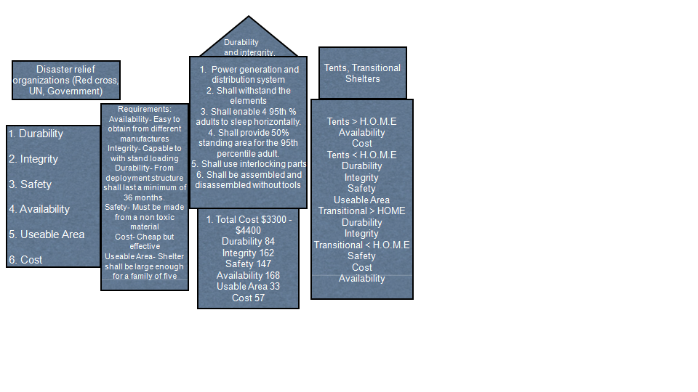
An important aspect to our project was doing the QFD analysis. This was a key component in understanding the major importance for the HOME emergency shelter. While working with the video provided by Professor Rousseau to get this done, we had to focus on the main aspect of the QFD’s. Each section was split up into seven different categories. In the first step the “who” describes the customer and the manufacturing company, and how our design can benefit them. The “who” consisted of the government, the Red Cross, and other relief organizations. The next step is the “what” this is the costumer’s requirement which describes the quality of the product whether it lasts long, to the assembly of the product. In our project we have multiple areas’s where quality is a key factor. Availability, integrity, durability, safety, cost, and usable area are the top area’s where quality needs to be shown. The availability of our product should be available from different manufacturers. The Integrity of our product should be able to with stand loading, and also it should be able to with stand the natural elements (rain, water, fire, and wind). The durability of our product is important as well, as engineers we want our product to not only perform well but also last longer than our competition. As our shelter lasts longer we also must look into keeping it safe this is another component in that what factor. The cost of the shelter must be in a reasonable price range as said by our sponsor to be bought by the “who” thus our materials should be researched well enough to ensure that our materials are durable and cost efficient. Useable area was our final requirement under "the what" category. The shelter must be large enough to hold a family of five and every space of the house must be useable since many of these families will be living in the shelter for a long period of time. The “who” versus the “what” is the third portion of the QFD, in which it describes the costumer’s top requirements of the project. The top requirements from the “what” are durability, integrity, safety, availability, useable area, and finally the cost, these would be the top on our costumer’s requirements list. The “now” category explains what type of shelters are used now by government agencies or humanitarian groups, which are transitional shelters and tents. Each of these plays a role in understanding which shelter is the best and where the costumer will get more for their money. Tents are easy to afford and easy to come by, where transitional shelters are durable but cost more than tents. Initially our product was to fall in between the tents and transitional shelter, but after doing research and getting quotes from manufacturers our shelter will cost more. It will cost more than a tent and transitional shelter. The fifth category is the “how”, here we find our engineering specification this goes off the “what" which is the costumers requirements. Our main aspect in the shelter will be power generation, since many of these shelters will be placed in locations where electricity cannot be found we have to figure out how and what distribution systems are needed to run the shelter for a long period of time. Following that it must be able to with stand high winds or heat like in Sudan or heavy rains in Haiti, to the coldest winters in Alaska. It shall also account for the ninety-fifth percentile of all adults to sleep horizontally without scrunching up and able to account for fifth percentage of adults while standing. The H.O.M.E system will use interlocking parts and shall be assembled and disassembled without tools in less than two hours. We want to make the shelter easy to understand and easy to build. We should always have in our minds that these individuals who have just lost their homes and belongings have nothing but their clothes on their backs and a few things to remember them of their last home. When we look into the “how” versus the “what" category, here we relate costumers requirements to the engineering specifications, and see if each requirement has a weak to high correlation. After all the math was done in this section our absolute important engineering specification was assembly followed by, natural elements, interlocking parts, power generation, water filtration, and the ninety fifth percentile. How much is the seventh category where we target a value for each engineering specification. Our shelter again exceeds the tents and transitional shelters at a cost of $9100 dollars. Lastly is the “how” versus “how”, here we see if any of our costumer’s requirements have any correlation between one another. In fact durability and integrity have a high correlation because our product has to be durable to insure the integrity.
Fig 1. Our QFD Diagram
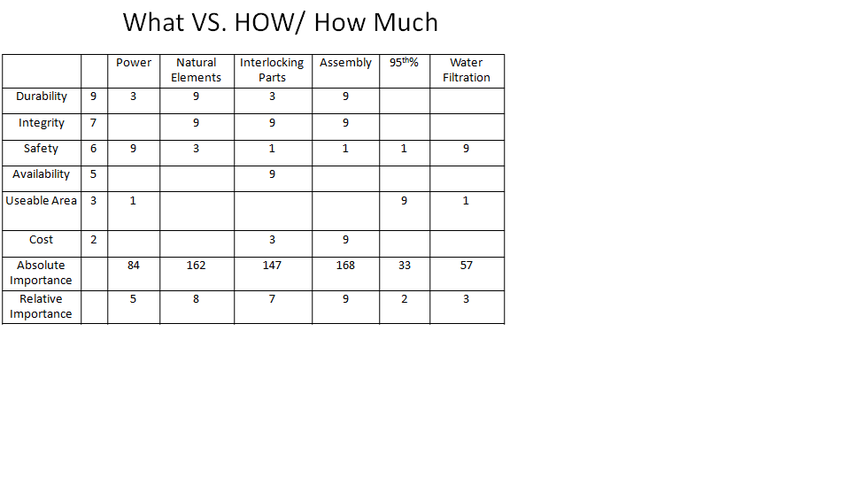
Table 8. What Vs. How/ How much
Fig## Our QFD Diagram

Table ## What Vs. How/ How much

Patent Searches

- Interlocking Floor System
No. US 2008/0072514 A1 Can be seen in Appendix A1-A8

- Wall Panel Unit
No. 4,107,892 Can be seen in Appendix A9-A14

- Modular Emergency Shelter
No. US 6,984,347 B1 Can be seen in Appendix A15-A21

- Storm Shelter
No. 6,948,281 B1 Can be seen in Appendix A22-A29

- Security Door System for sliding screen doors
No. 5,575,321 Can be seen in Appendix A30-A36

Evaluation of Competition
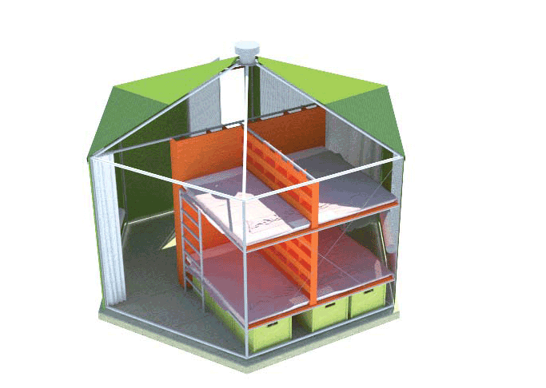
There are other forms of shelter available for the use. Governments and relief organizations use three types of shelter: emergency, transitional and permanent. Each has the own pros and cons as outlined in earlier sections. There are also commercially made shelters available, for example the Softhouse designed for the Haiti relief effort. It provides a 166 square foot octagonal living space. It takes one day with a team equipped with 3 socket wrenches, a 10 ft and a 6 ft ladder and training to completely assemble [6]. The Softhouse also needs to be assembled on a concrete slab to anchor it to the ground. The actual price of the unit was unable to be found as the project seemed to be unable to gain funding and has had trouble getting off the ground.
Fig 2. Haiti Softhouse
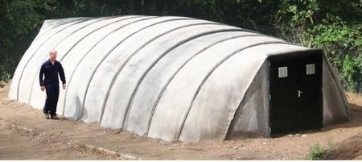
Another unique design we found in our research was the Concrete Canvas Shelters. They are an inflatable canvas that is made out a cement impregnated fabric. These are easy to deploy and set up, if you have access to a fork lift, ample water supply and machine tools. They have a life span of 10 years and are designed for use as medical centers in crisis areas and cost ranging from $1250 for a small unit to upwards of $5000 for bigger units [2].
Fig 3. Concrete Canvas Shelter
The HOME system combines the positives of the other forms of shelter and eliminates the negatives. It is designed for easy assembly by only two untrained adults in 2 hours. A simple to follow IKEA style assembly manual is provided with each HOME, it can be seen in Appendix A61-A72. There are minimal parts to reduce confusion and potential of failure. The HOME can be assembled without any power tools, making it much easier to deploy into relief areas without having to provide other utilities. From the rigid design and materials used, the HOME will last for many years. It is usable until something catastrophic happens to it. This would be an event that would cause forces over 600lbs to the structure causing the HDPE panels to bend out of shape.
The two features that set the HOME apart from the other forms of shelters available are the water and power systems. The roof panels have been design by the RWU team to guide rain water to collection points on the roof. That water then passes through a piping system that utilizes a first flush diverter. This is a mechanism that collects the first half liter of water that comes through the pipes and separates it from the rest of the water collected. Eliminating most of the different contaminates that would come off the roof. The remaining water is stored in a large tank on the outside of the HOME. Water purification tablets are supplied with each HOME unit and are also generally provided by relief organizations running the camps. The power cap is interconnected to the central column and the roof panels. It consists of an array of solar panels that charges batteries that are housed in the central support column. The column also contains the wiring to LED lights installed on the underside of the power cap and a hand crank attachment that allows for manual power generation. These are the features that make the HOME a better choice for relief efforts around the world.
Specifications Definitions
The design specifications have remained unchanged from what the system requirements document had set. The sponsor had already interpreted the requirements into engineering terms when giving them to the team. The aim of the work done in the past months was to see if requirements were met through analysis, inspection, or testing. The full system requirements document is too long to include in the main body of the report but will be available for reference in Appendix A52-A60. The main requirements for the HOME are to meet UN guidelines for shelters, be self-sustaining, be able to withstand forces that could be applied by a 95th percentile adult, waterproof and easy to assemble.

Conceptual Design

List of Concepts Generated
- Over All Shape
In the design of the overall shape of the HOME many different ideas came to mind. These include the traditional shelter shape of a rectangle or square, the sponsor’s original concept of a geodescent dome and finally a regular hexagon, all of which can be found in the appendix.

- Wall Panels
The main obstacle of designing the wall is how each wall will interface with one another. Again many ideas were generated for this topic. These include interlocking hook designs, pin and hole designs, ball and cup snap designs, interlocking pin designs and finally a long pin that will slide all the way through interlocking keys. All of these designs can be seen in the appendix.

- Floor Panels
The most difficult hurdle in designing the floor panel again is how these panels will interface with one another since most of the concepts can be integrated into any shape of the HOME in one way or another. The concepts that were brainstormed can be found in the appendices’ of this report. These concepts include the use of compression to hold the panels together in the form of a compression ring, a concept that includes slots and extrusion on opposite sides of one another that will fit together, but further thought into this design lead to the pin and hole design were there will be a number of pins and holes, in which the pins will fit concentrically in the holes.
- Roof Panels
The conceptual design of the roof panels have several main factors involved in them. These include how they interface with the wall panels, how they will interface with the center power cap, and how they will interface with the other roof panels. They need to protect the occupants from the environments that the HOME will be utilized. Examples of designs that were conceptualized include an interface with the power cap in a hook style, and a concept that includes flaps and an extrusion located were the wall and roof panel connect that extrudes from the roof and slides into a slot within the wall panel. These design concepts can be seen in the appendices section.

- Door Design
The door design undoubtedly must include moving parts, which in this project is something that is to be minimized as much as possible and is an important criteria that the sponsor has focuses upon. To do this on an object that has to move is quite difficult, so from this the next major factor is to design the function of the door that is very reliable and in no way will ever fail or brake during the life of the HOME. This door will have to endure many damaging environmental effects including extreme changes in temperature, possible strong winds and the infiltration of sand from desert like conditions into every nook and cranny of the door. Conceptual designs for this include a ball and cap snapping interface between the door and wall and a design that includes variations of your classic hinge design, more specially a pin and hinge design.

- Gaskets
There will be several different set of gaskets used with the assembly of the HOME. These gaskets will be on the interfaces of the wall to wall, roof set to roof set, half roof to half roof, and wall to floor. These will not only be used to help seal the interior of the HOME for the harshest of weather but also to create an easy of tolerances when assembling the HOME. The rubber material will give some play to the panels in their assembly again to be able to build the HOME without the use of tools.

Evaluation of Concepts
- Overall Shape
The overall shape that has been chosen is that of the hexagonal shape after careful engineering consideration, also with simple thought and reasoning. Reasoning’s for ruling out the geodescent dome concepts is the use of area for the occupants of the HOME. In a shelter such as this the floor space and overall volume of space to be used is to be maximized as much as possible, which the geodescent dome lacks because of the curved walls which takes away from volume to be stood in making it difficult to allow for the 95th percentile to be able to live within the HOME. Also these curves cause another problem which is that it complicates the assembly of the product, which is to be assembled without tools and equipment by untrained individuals. The rectangular or square overall shape of the shelter was ruled out for similar reasoning’s as the dome, including the maximum floor space that was necessary for designing the shelter. This is what leads to the decision of the hexagonal shape that gives a great usage of floor space while still keeping the design simple and also when using a regular hexagon, makes each type of panel (wall, floor and roof) all the same, with the only variations being for the two doors in the wall panels.

- Wall Panels
Now that the overall shape of the shelter had been finalized, all the other design concepts can be finalized and utilized in this formation. The design concept that has been chosen for the wall to wall interface is one in which the walls will include multiple keys and slots, chamfered at 60 degree angles from the outer surface of the wall towards what will become the interior of the shelter. This chamfer, when all walls are connected will bring the hexagonal shelter full circle to connect with the beginning wall. Within the keys and slots of the walls and hole will be drilled all the way through, from top to bottom, in which a shaft will be slide through to hold the walls together. This will give the walls of the shelter the support necessary to hold together through the trials and tribulation this shelter will undergo throughout its use. Also to connect the wall panels to the base floor panels, pegs will be extruded from the base of the wall that will connect into the floor panel, holding them together without the use of fasteners. Finally running along the top of the wall panels will be a slot to create an interface with the roof panels for structural integrity and sealing the interface from the elements the shelter will be utilized in.
Also to reduce the weight of the wall panels, the wall will be made of several different pieces that will be manufactured and assembled before being deployed to create a singular panel, this not only cuts down on the weight of the structure but will also make the manufacturing of this panel and similar processes for the other panels using an Ultrasonic plastic welder, to join separate pieces to form a single panel. In the wall panels case the design is to have 1.5”×4” ×6.5’ studs to be welded onto sheets of the HDPE material that are .25” thick. This will resemble what an unfinished wall in a typical home would look like and where the idea was cropped from. The studs will be 16.5” apart following normal housing design specifications. With this process it will create wall panel with acceptable weight while still keeping its structural integrity.

- Floor Panels
The final concept that had been chosen for the floor panels was mostly based off the way in which the floor panels to floor panel interface would work, as most of the concepts could be integrated into whatever overall shape of shelter was chosen. So since the hexagonal shape has been decided upon, to minimize parts it makes sense to have each floor panel be that of a equilateral triangle coming together to for the base of the hexagonal shape. From there an analysis was done to make the decision as to what interface would be choose, which is that of a pin and hole design in which opposite interlocking pin and holes will connect each panel together holding them in place, again without the use of any fasteners. Also holes are placed along each edge of the floor panels so that the wall panels will insert into the floor panels holding them in place giving them support and structural integrity. Through testing of the HDPE material it was decided that the number of pins and holes was adequate along with FEA analysis of the pin and hole design. Also the addition of J-shaped gaskets between the floor and wall panels will be made. This is not only to ensure sealing of the interior from the weather but also to add tolerance in the assembly of the HOME.

- Roof Panels
Again now that the overall shape of the shelter has been decided upon, the roof panels can now be evaluated. The roof panels will have the shape of a trapezoid, to allow connection to the center column and power cap system being designed by the Roger Williams design team. The roof panels will have a pitch of approximately twenty degrees, to come to the center at about 7.5 feet. At the interface of roof panels to the wall panels three extrusions will be made, one that will rest on the outer edge of the walls to create a seal from the elements, an extrusion in the center that will slide into the slot in the walls adding structural integrity. Finally an extrusion will be resting on the inner edge of the wall to act as a seal and also to resist any torque the will be applied atop the roof panels.
Also to account for the weight of these panels it has been decided that the panels from the original design will be cut down the middle from the top of the panel to the bottom. This will obviously cut the weight of the panels in half. Also the panels will be manufactured from separate pieces onto a base .25” thick panel using the Ultrasonic plastic welder again allowing for easy of manufacturability and greatly reducing the cost of manufacturing the panels. This halving of the panels does cause there to be the need of an additional gasket to run between each half panel to seal the panels from the exterior weather. To connect each half of the panels there will be a series of pin and hole sets, running from each roof panel and also through the gasket. This will ensure structural integrity of the roof panels in case a load were to be applied upon the roof panels.
Now regarding the interface of roof panel set to roof panel set there will be the addition of a gasket using a tongue and groove system. The gasket will run from the top of the roof panels to the bottom of the roof panels creating not only a seal from the weather but also to allow for tolerance in the assembly of the HOME and hopefully making it easier to assemble.

- Door Design
The final door design that has been decided upon is that of a hinge design in which a pin and hole design will be utilized. There will be three sets of hinges using the HDPE material in which there will be a pin portion attached to the door panel and a hole set attached to the door which will meet to form a structurally strong hinge in which the material used will allow for a long life of use.

Design For X
The assembly of the HOME was an important factor during the design of the project. Giving the fact that we were to have no moving parts and not tools to put the HOME together was a challenge. We went about drawing up many concepts to help solve this problem. Interlocking parts became our top choice for our design, it gave us the easiest way to assemble and disassemble the HOME without the use of tools. As for a manufacturing the HOME, we found that welding the plastic together using an ultrasonic plastic spot welder would make the assembly of the HOME easier, cheaper and with less labor involved. Also by changing the thickness of the wall and cutting the roof in half it will make the HOME easier to install for the builder.
The way we designed for durability and integrity was to find a material that was strong enough to handle all of the specifications that we were looking for. After looking into many different plastics we came across HDPE, a plastic that fit all of our specifications. The next step was to test the material and receive results on how the material would perform in our product and situations we believe it would be utilized, to do this we used the Instron testing machine in which we did tension tests. Also we tested the material in the wind tunnel to test wind speeds at the joints of the model. Once the tests were done and each of us pleased at the results, we chose this HDPE to be our material.
The design for the cost was a major part of our project. Our goal was to make the HOME very accessible within cost; we initially estimated the cost to be roughly 4000 dollars. We said that the panels would be two inches thick at first which drove the cost of the HOME higher than the original estimate. Changes needed to be made so we trimmed the size of the wall panels to a quarter of an inch, and applied studs to the walls to make the structure light and while not losing the structural integrity. This lowered the cost but it was still not enough to get us to our original cost estimate. The cost of the HOME today would be roughly 9043 dollars.
The design for safety was also important in our project. While reducing as many materials to make the cost lower we had to keep in mind the safety of the people who one day would be living in this structure. The HOME had to be able to withstand forces while still staying sturdy in all the elements. It had to withstand a person standing on the roof and overall it had to be a strong enough material to do so. Another important aspect of finding the right material that was food safe where one day a person could grow food from the side of the HOME as our sponsor wanted it to do.

Detailed Product Design
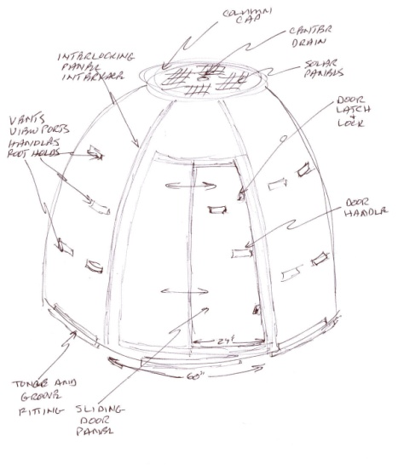
Throughout the year, the HOME shelter has evolved and taken many different forms. Originally when the Mr. Davids presented the project to the capstone class, the rough design of the shelter was based off a geodescent dome. As we embarked upon the project it was quickly realized that the geodescent dome shape was most likely not the direction the team wanted to move forward with. Through careful thought based on the specification and application for which the shelter would be utilized, the decision was made to use a regular hexagon and the team moved forward. The other systems that would be tackled this year, the electrical power and water collecting, was left to the RWU team to handle because of their expertise in electrical engineering. They also went through several design changes and modifications throughout the year.
Fig 4. Mr. Davids’ original concept
With the overall shape decided upon, concept generations of the individual panels and supporting pieces, that were needed to assemble the HOME shelter, the team could continue to move forward with designing the finer details. So first the large panels, wall, floor and roof panels had to be designed to get an overall view of what the shelter would look like. Using the UN standards for floor space for this type of shelter, rough dimensions were used to begin designing these panels. Also a major factor to the design of the panels is how they connect with one another. This was a major focus of the concepts the team generated.

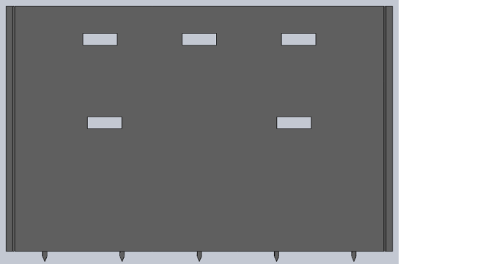
The wall panels dimensions are based off the height of a 95th percentile of a male and the area desired for the shelter. Leading to a length of 7.5 feet in the horizontal and a height of 6.5 feet to allow the 95th percentile to be able to stand next to the wall comfortably, and also the length allows this percentile to be able to lie along the full length of the wall, utilizing all possible floor space. To allow flush mating the walls must be chamfered from the outer surface towards the inner at 60 degrees at each end of the wall, this will, when the walls are connected for the walls to create the regular hexagonal shape.
Fig 5. Original Wall design.
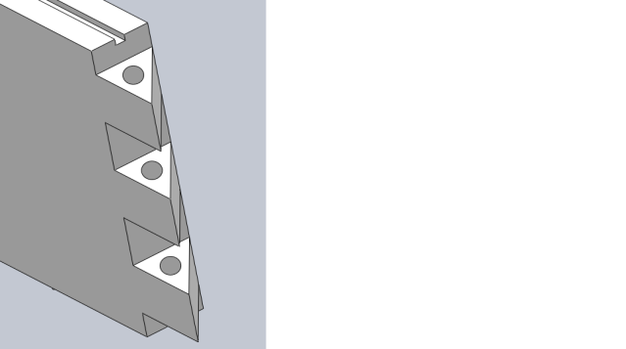
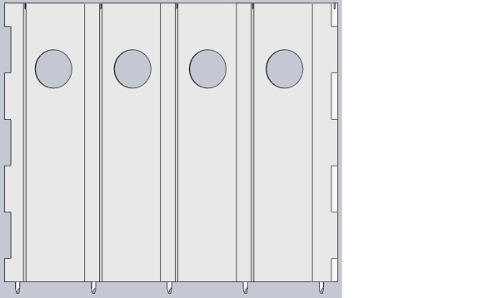
Now with these factors being designed, the next objective in designing the wall panels was the way in which the wall panels will interface and connect without the use of fasteners and tools. To do this many concepts was generated, analyzed with careful thought and simulation. Figure ## on the left had the wall panels coming together and then another piece that would need to be machined would be slipped down the grooves connecting the two wall panels. This concept was scrapped because the need to machine another piece. The final concept was decided upon which can be seen in Fig##. This is in which a system of keys would be used on the vertical edges of the walls, creating a flush mate. Then to ensure the panels would stay together and to give the shelter structural integrity, HDPE stringers at ½’’ diameter slide through the holes, connecting wall panel to wall panel. Finally so that the wall panel would connect to the floor a system of pegs were designed to insert into the floor panels, which will be discussed later. The wall panels were also made lighter by reducing the amount of material in them. The original wall panels weighed 312lbs, this would be very difficult for two adults to handle. The panels are now much thinner and use studs to maintain strength. The final wall panel design weighs 125lbs.
Fig 8. Final Wall to wall interface
Fig 7. One concept for wall to wall interface.
Fig 9. Final wall panel
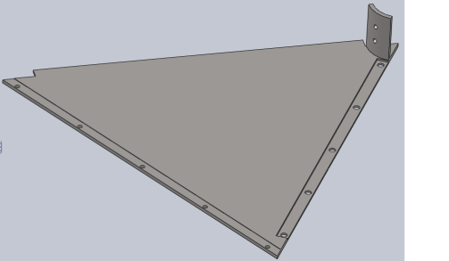
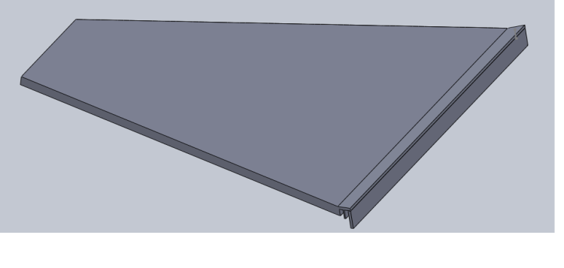
The floor panels were the next design to be tackled by the team. To create the hexagonal shape the floor space to be used based on the UN standard and guidelines were taken into consideration, this being that we need over 130 sq ft of usable floor space. From this and also designing the floor panels to match up with the wall panels the dimensions were decided upon. To create the hexagonal shape with the least amount of parts it made sense to have 6 floor panels that would interlock. Leading to the decision that each floor panel shall be the shape of an equilateral triangle, in which the final design concept can be seen in Fig 10. As in the wall panels a major design point was how the panels would interlock. To do this, a pin and hole system was created in which one side of the triangle has the pin and the opposite side of the receiving panel had holes for which these pins would lock into, creating a flush connection. Also another design point was the way in which the wall panels would lock into the floor panels. This was done by having receiving holes designed into the floor panels for which the pegs of the wall panels would connect through and into the ground creating a foundation for which the shelter will stand upon. The pins also work to secure the structure to the ground. Stress analysis was done on these connections and can be seen in the Engineering Analysis section.
Fig 10. Final floor panel
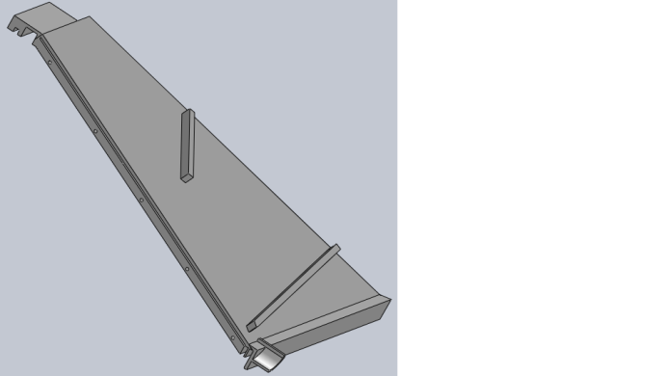
The next major panel to be designed is the roof panel. Again to create a hexagonal shape and allowing the roof panels to interlock with the RWU teams power cap designed, the overall shape of the roof panel was determined to be that of a trapezoid that would be pitched at approximately 15 degrees on the top face. This original design was deemed unfit because the weight of the panel was unreasonable and unsafe for two people to be lifting over their heads. To reduce the weight of the panel, they were cut in half and made thinner with studs attached to keep structural strength and a pin system to connect each half roof panel. The final roof panel weighs 52.5lbs a piece. This is much lighter than the original and allows for two people to easily assemble. The grooves are part of the water collection system designed by the RWU team. They guide the rain water to the middle of the panel and the water is then sent through pipes to the collection tank.
Fig 11. Original Roof panel
Fig 12. Final Roof panel
The final panel designs were reached by considering ergonomics, easy of assembly and cost. The reduction of material in all of the panels significantly lowered the cost of the HDPE sheets purchased for manufacturing. The original thickness of 1- ½ ’’ HDPE sheets would cost $739.58 each. The new thickness of ¼ ‘’ only cost $114.23 each. The studs would be made from 1- ¼ ‘’ HDPE and those sheets cost $336.64 each. The original panels would cost over $18000 in material costs while the final panels cost under $4000 for material costs. This caused us to conclude that our final design for the panels was much better than our originals.

Engineering Analysis
Finite Element Analysis – Using Solid Works
- Wall Panel Analysis

- Compression

This simulation was done as if a 250lb man was standing at top the wall. To represent this load, a distributed load of 111N was applied along the top of the wall. To fix the wall, each peg that would be inserted into the floor panels was rigidly fixed.
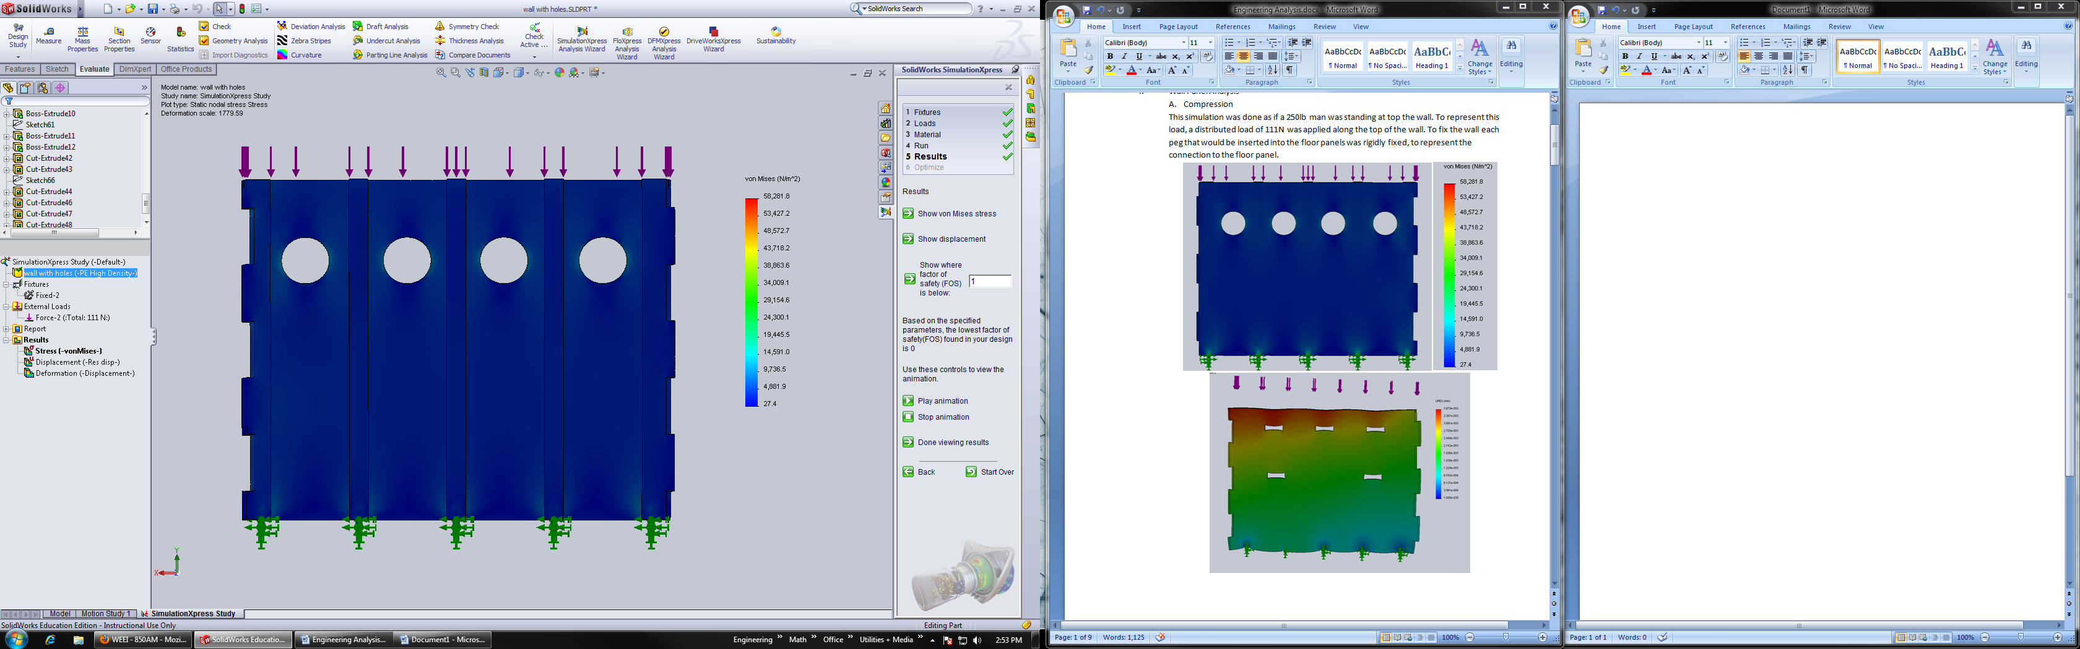
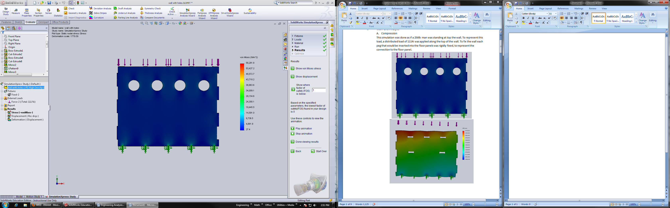

Fig 13. Shows Von Mises stress distribution through the wall panel fixed at the bottom and under compression

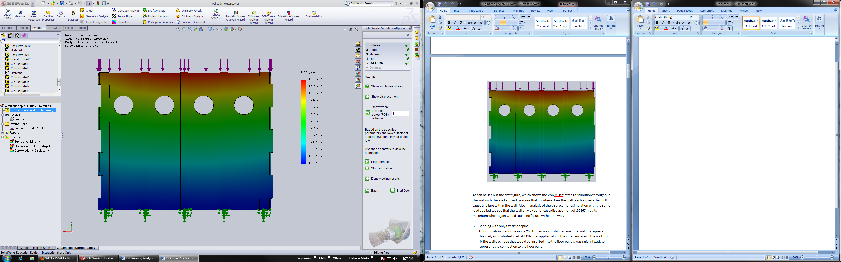
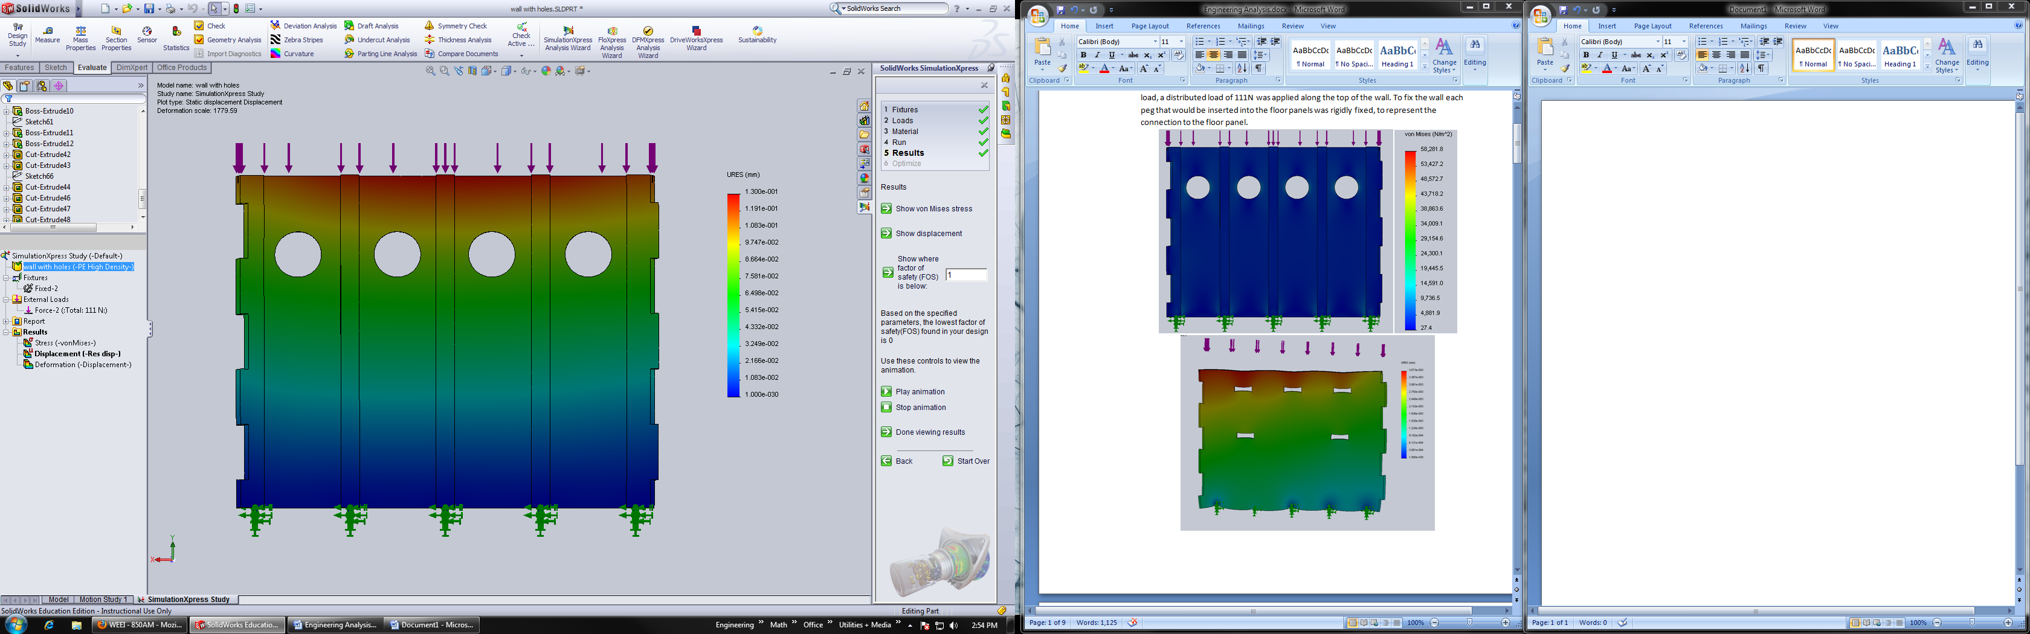
Fig
Fig 14. Shows the displacement distribution (mm) through the wall panel, fixed at the bottom and under compression

As can be seen in Fig 13, which shows the Von Mises’ stress distribution throughout the wall with the load applied, you see that no where does the wall reach a stress that will cause a failure within the wall when the yield strength of HDPE is about 33MPa. Also in analysis of the displacement simulation with the same load applied we see that the wall only experiences a displacement of .00013m at its maximum which again would cause no failure within the wall.

- Bending with only fixed floor pins

This simulation was done as if a 250lb man was pushing against the wall. To represent this load, a distributed load of 111N was applied along the outer surface of the wall. To fix the wall each peg that would be inserted into the floor panels was rigidly fixed, to represent the connection to the floor panel.

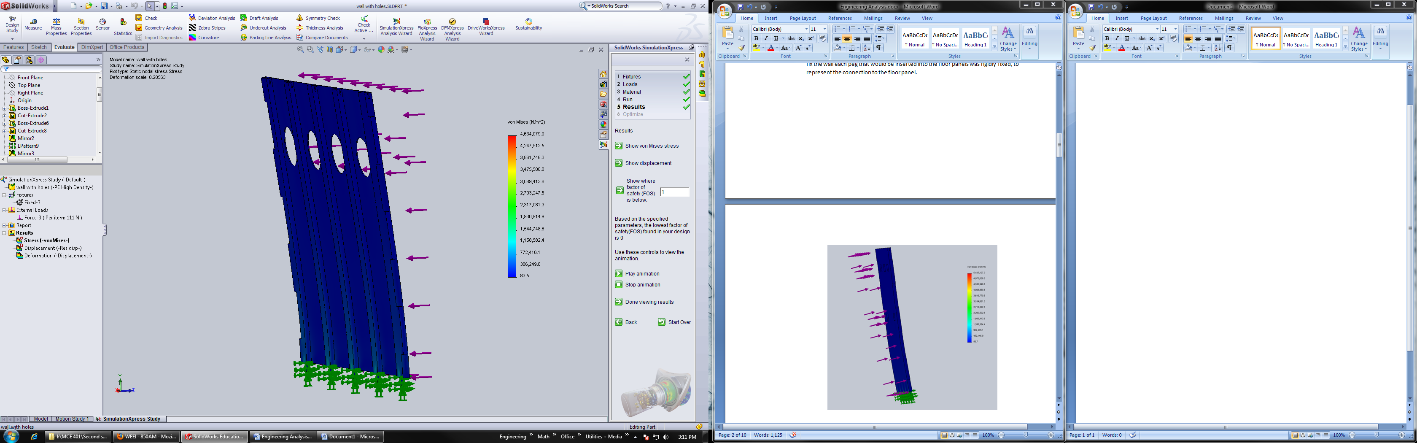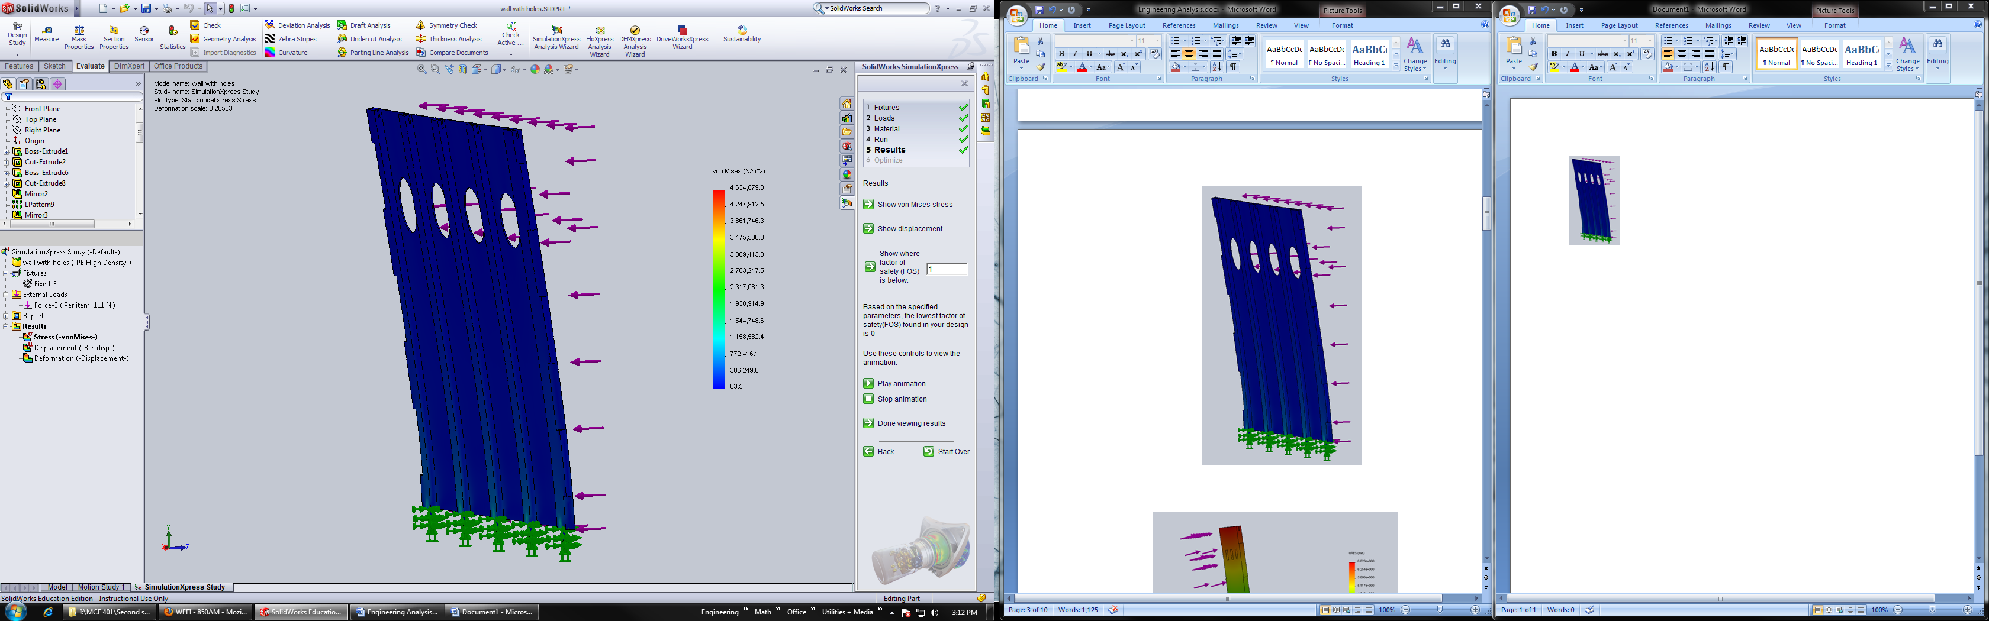

Fig 15. Shows the Von Mises Stress distribution throughout the wall panel fixed at the bottom pins
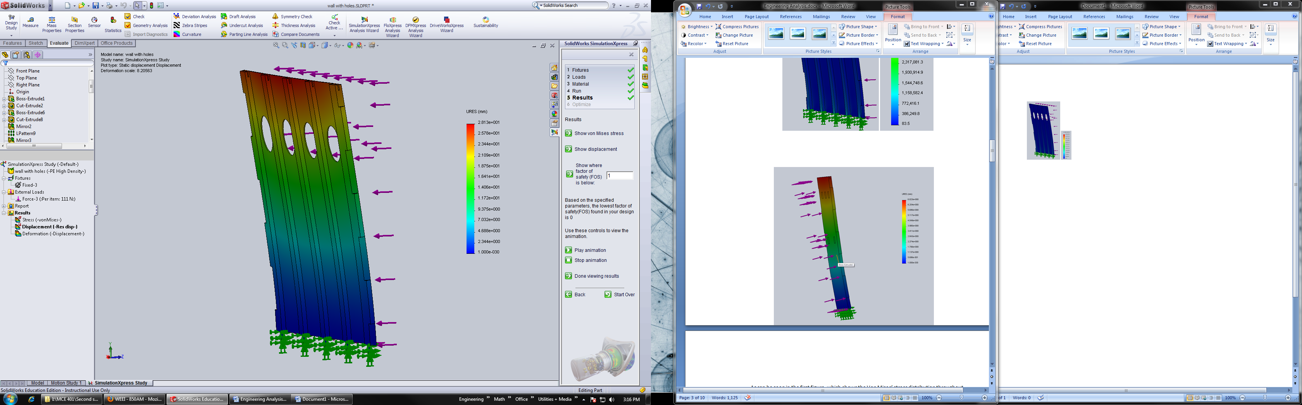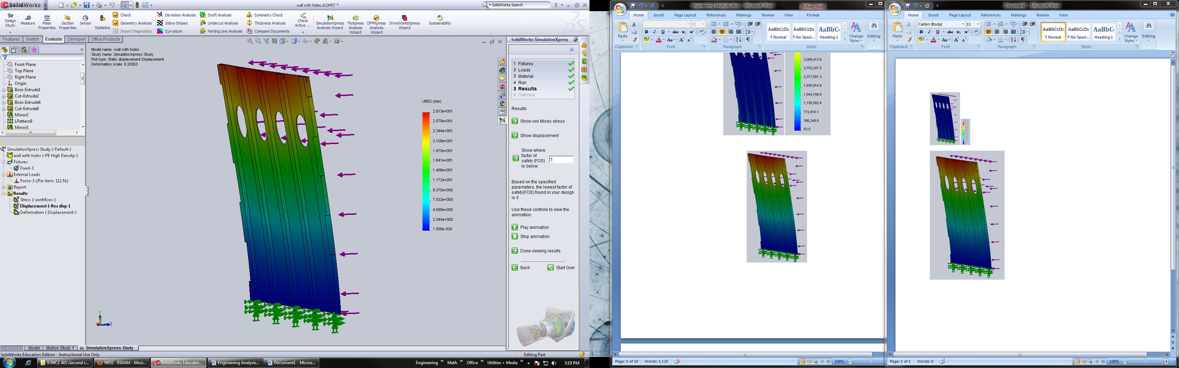

Fig 16. Shows the displacement distribution (mm) due to an applied load, fixed at the bottom pins

As can be seen in the first figure, which shows the Von Mises’ stress distribution throughout the wall with the load applied, it is seen that nowhere does the wall reach a stress that will cause a failure within the wall with a maximum stress concentration of 4.6 MPa. Also in analysis of the displacement simulation with the same load applied we see that the wall only experiences a displacement of 28.13mm at its maximum which again would cause no failure within the wall.

- Bending with floor pins and wall/ceiling panel interface fixed

This simulation was done as if a 250lb man was pushing against the wall. To represent this load, a distributed load of 111N was applied along the inner surface of the wall. To fix the wall each peg that would be inserted into the floor panels was rigidly fixed, to represent the connection to the floor panel. Also the slots designed for the wall to roof panel interface was fixed rigidly to represent the wall as if it was fully assembled.
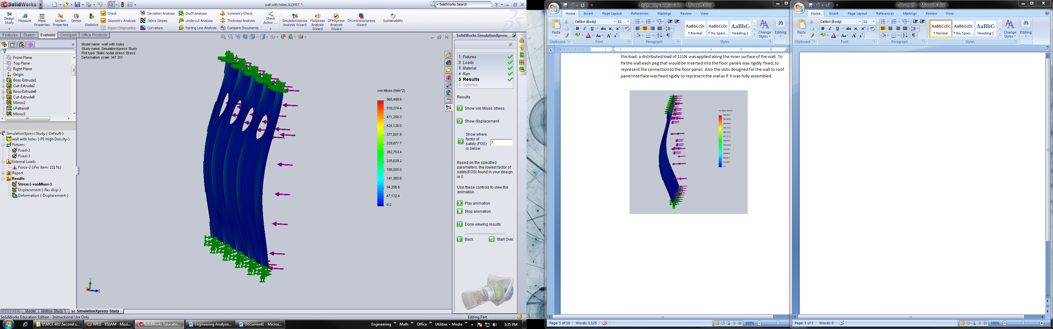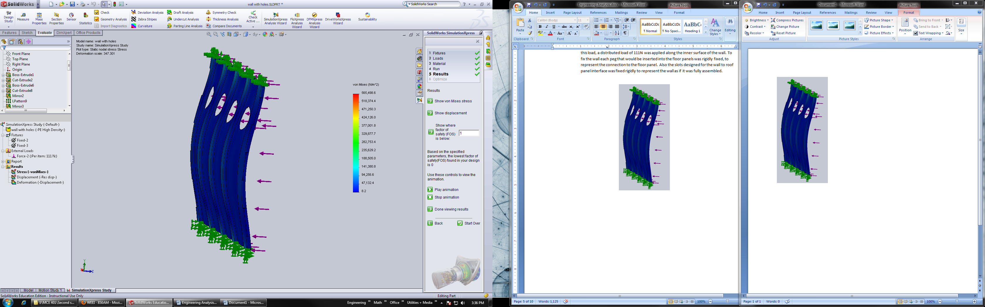
Fig 17. Shows the Von Mises Stress distribution through the wall panel, fixed at the top and bottom interfaces
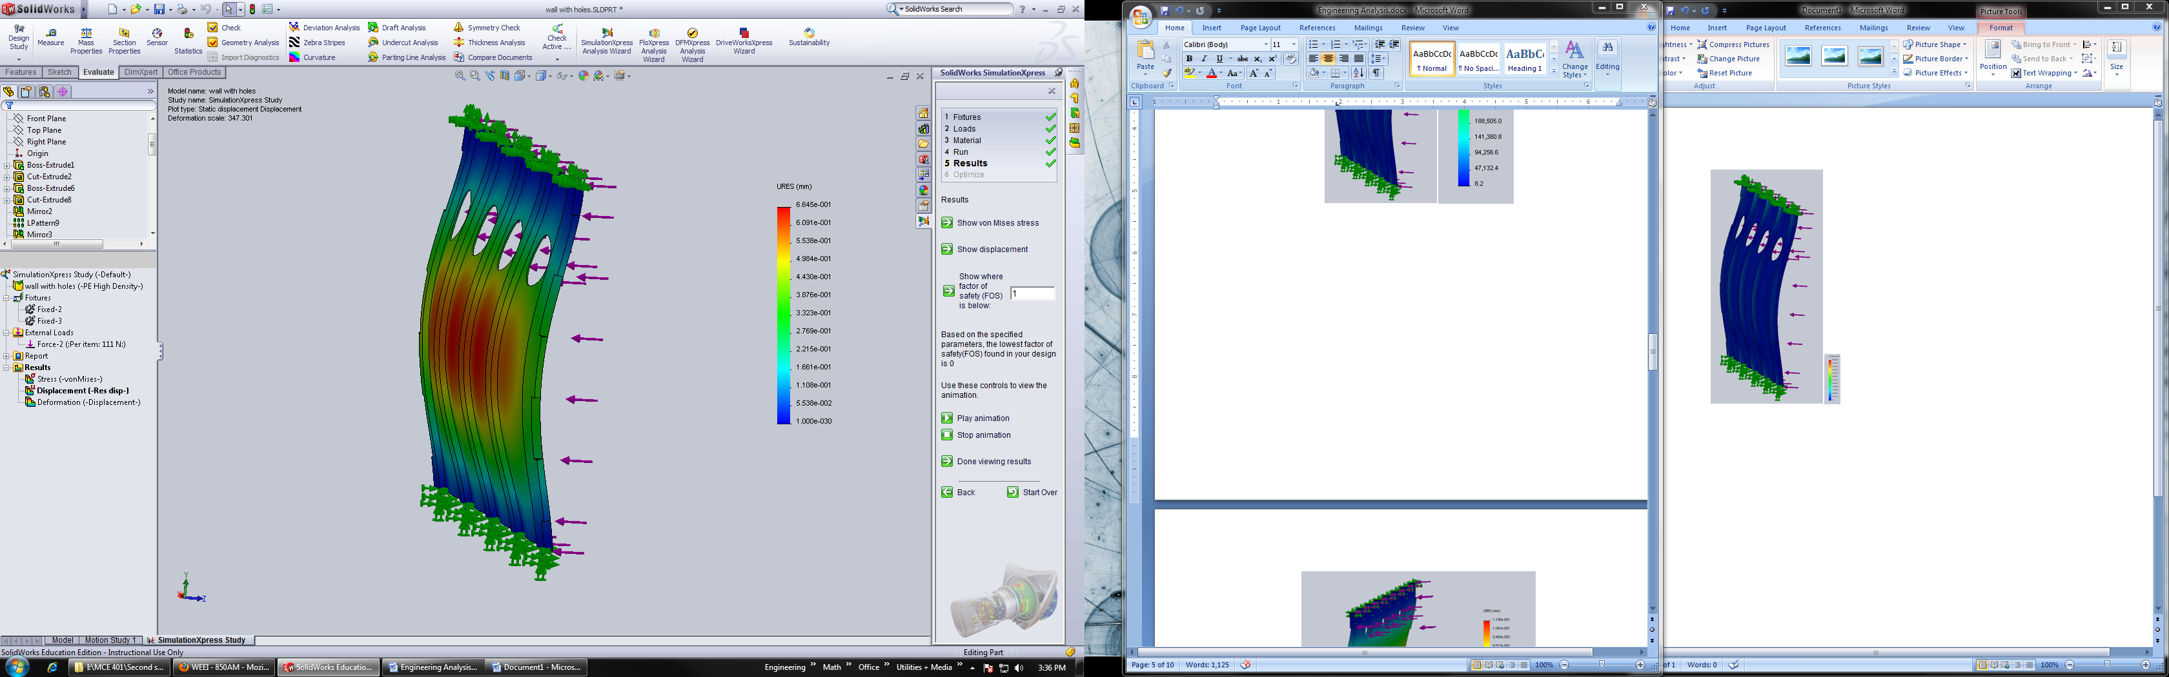
Fig 18. Shows the displacement distribution (mm) through the wall panel, fixed at the top and bottom interfaces

In analyzing the Fig 17, it can be seen that the wall panel will experience no stress concentration that will induce failure of the wall with a maximum stress concentration of approximately 565KPa. In analyzing Fig17, it can be seen that with this load applied, a displacement maximum of.665mm of occurs. Comparing these results to the previous designs, shows that the new design is just as structural sound and the material will have not be used past any point to which failure will occur.

- Floor Panels
- Fixed pins
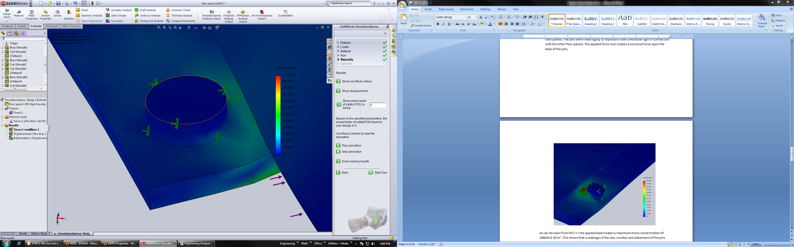
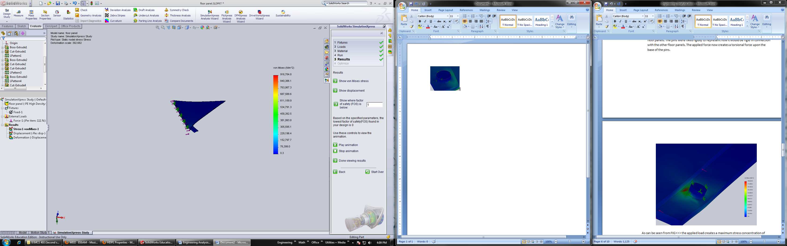
This simulation was done upon the floor panels. Since the floor panels will be supported by the ground beneath, the main focus of this analysis will be that of the pins being used to connect floor panel to floor panel. To do this and to keep conformity in forces being simulated, a load of 111N was placed upon the edge of the groves used to connect the floor panels. The pins were fixed rigidly to represent how it would be rigid in connection with the other floor panels. The applied force now creates a torsion force upon the base of the pins.

Fig 19. Shows the Von Mises Stress distribution through the a pin through the floor to floor interface system

As can be seen from Fig 19, the applied load creates a maximum stress concentration of 917MPa. This shows that the redesign of the size of the pins and the distance into the panel that they are located successfully helped strength the pin, which will lead to no failure occurring within the material to be used. The figure of the displacement of the pins in this case was not shown because no significant displacement was recorded in the simulation.
- Hole for pin
This simulation was done upon the floor panels. Since the floor panels will be supported by the ground beneath, the main focus of this analysis will be that of the holes used for the interface of floor panel to floor panel in which the pins in the previous simulation will be concentrically mated. To do this and to keep conformity in forces being simulated, a load of 111N was placed upon the edge of the groves used to connect the floor panels. The holes were fixed rigidly to represent how it would be rigid in connection with the other floor panels. The applied force now creates a torsion force upon the holes.
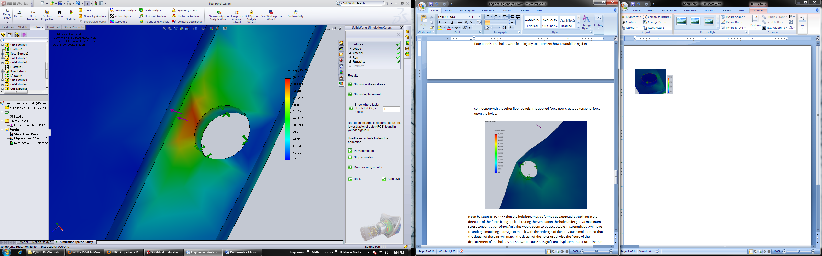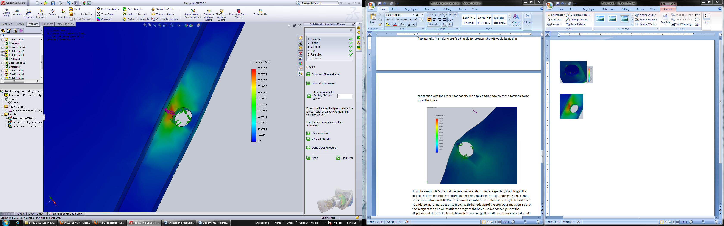
Fig 20. Shows the Von Mises Stress distribution through the hole in the pin and hole system in the floor to floor interface

It can be seen in Fig 20 that the hole becomes deformed as expected, stretching in the direction of the force being applied. During the simulation the hole under goes a maximum stress concentration of 88MPa. This was also redesigned along with its pin portion of the floor to floor interface. This moving of the hole further into the panel helped further strengthen this interface, even though the previous design was adequate. Also the figure of the displacement of the holes is not shown because no significant displacement occurred within the simulation.

- Roof Panel

- A FEA analysis was done upon the right roof panel to see how the current design will react as if a 55.5lb force, or half the weight of a full size male was to have his weight distributed on top of the panel, which is a specification that the sponsor has communicated that the roof panel and shelter its self must be able to with stand. To represent this action in simulation a distributed load was applied with the magnitude of 111N. The roof panel was rigidly fixed at what is to be the interface of the roof panel to wall panel, simulating as if the roof panel was connected to the wall panel.

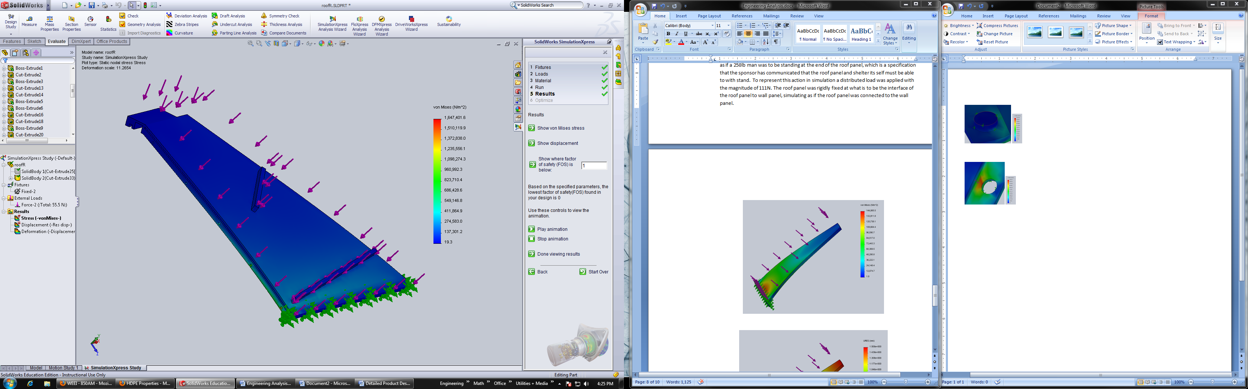

Fig 21. Shows the Von Mises Stress distribution throughout the roof panel fixed at the roof to wall interface

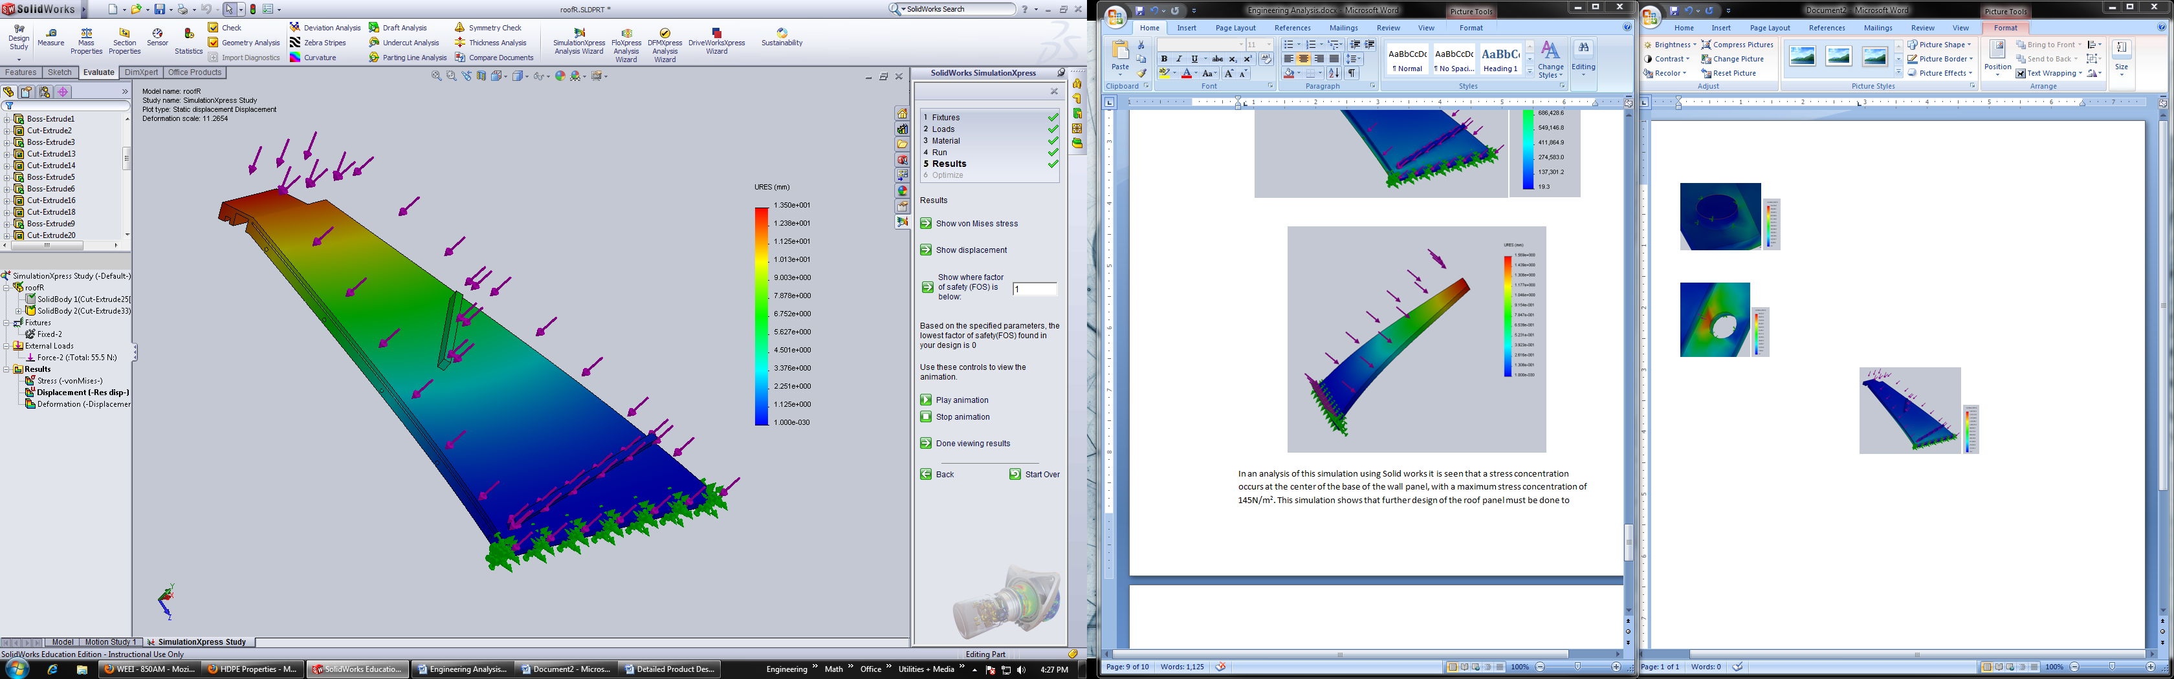

Fig 22. Shows the displacement distribution through the roof panel, fixed at the roof to wall interface
In an analysis of this simulation using Solid works it is seen that a stress concentration occurs at the center of the base of the wall panel, with a maximum stress concentration of 16GPa. This shows that this panel should be adequate in not failing under such an applied load. Also that the redesign from the original roof panels of the addition of material at the interface of the wall and roof panel, were the highest stress occurs and others to strengthen the panel. Also it shows that the cutting of material in places that it could be allowed to make these panels as light as possible was a success because no lost in structural integrity occurred. In analysis of the displacement of the roof panel in Fig 22. a maximum displacement of 13.5mm occurs. Again the weight cutting and redesign of the panels, was acceptable and caused no loss of structural integrity that would cause concern.

Manufacturability
Manufacturing of Prototype
For the manufacturing of a prototype of the HOME we used a rapid prototype machine to create a 1/.08 scale model of the HOME. We chose to do this because the size of a real size HOME would be outside the abilities of the URI team and beyond the financial abilities of the sponsor. We felt using this rapid prototype would be a very useful model to place within the wind tunnel and use for assembly tests within our testing of our design. There are some difficulties that come with making a full scale model into such a small scale. A lot of this was due to the capabilities of the rapid prototype machine and the strength of the material used to make the prototype.
To be able to scale down the full scale solid works models into the scale that the rapid prototype would be capable of creating several of the interfaces had to be altered from what the final design would be like. To start the stringer system used for the wall to wall interfaces had to be changed to a ball and cup system. This had to be done because within the full scale model the stringer system calls for .25 radius holes through the wall interfaces which when scaled down would be far too small for the rapid prototype to create. This in turn makes our prototype lacking in the ability to test this interface in any way that would give comparably results, so our team in turn did another set of tests to conclude the wall interfaces would have the necessary strength needed.
For the wall to floor interfaces the pin and hole systems utilized was changed slightly again to account for the scaling of the model, the team made the holes further back into the floor panels and made the holes a larger size. A similar process was used for the floor panel to floor panel interfaces. This design was then utilized into the full scale design because it was thought to be a more effective interface that would be more stable with more surface area of the panels overlapping one another.
Another alteration between the full scale computer model and the scaled rapid prototype is that the wall panels must be made thicker in order to be sure that it could be removed from the support material used within the prototype machine. This essentially created exaggerated studs upon the wall panel. The construction of this prototype was very successful in that it gave us a table sized model in which we can show our proof of concept in a visual manner as well as using the prototype in several fields testing.

Manufacturing of the HOME
For the manufacturing of the HOME the most efficient way would be to manufacture each panel in an assembly line format. There for each panel would include its own system of assembly. A major portion of the assembly would include using several different manufacturing tools including a CNC and the use of an ultrasonic plastic welder both of which can be automated, which would be the most efficient in the long run and most cost effective for mass production.
Wall Panel
For the wall panel the basis of manufacturing would start with .25” thick HDPE, either custom cut to the size necessary 6.5’x 7.5” or use two 4”x8” panels cut down to size to make the basis of the panel based on a cost analysis due to how many HOME’s are to be manufactured and the cost of custom cut sheet or the standard size sheets. These sheets, using a CNC, must be cut to create the key system interfaces and chamfered at a 60° again to start to create the wall to wall interface. From here the two wall interface support portions that are on the interior of the walls must be cut out using CNC using 1.25” x 6” x 6.5’ stock or the available stock that will allow for this size of HDPE following the given drawings that will include again matching keys chamfered at a 60°. Also the stringer holes must be now drilled to a diameter of .5” and be drilled from the top to the bottom of the supports, through all the keys as seen in the drawings. Next the three studs must be CNC cut to a size of 1.25”x4” x 6.5’ again following the modeled drawings. Along the bottom of the studs and the two wall interface supports holes must be drilled to accompany the pegs that will be utilized in the wall to floor interface and will be drilled to a depth of 2”. These pegs will be 5” long and have a diameter of 1” and be made out of HDPE. Now using the ultrasonic plastic welder, these five supports must be attached to the base of the panel, the sheet of HDPE, using a series of welds down the wall, through the base panel and into the support systems. This welding can either be done using a hand held welder or be automated depending on the system chosen. Also the addition of the pegs should be now which includes placing the pegs into their accompanying holes and will be welded using a hand held on both sides of the panel to ensure a quality bond to the interface.
Roof Panel
The half roof panels starts again with the base sheet of .25” HDPE which will be CNC out of a 4’x 8’ sheet according to the modeled drawings given to the machinist. A similar process used in the manufacturing of the wall panels, of welding support and interface portions to the base sheet will be utilized in the manufacturing of the half roof panels. These support portions will run along the perimeter of the CNC sheet of HDPE that now has a trapezoidal shape. There must be some CNC work done to two of the perimeter supports, the ones that would be considered the sides compared to the bottom and top perimeter supports. These side supports must be CNC to accommodate for the gaskets systems that will run between the interfaces and also for pins to be run from half roof panel to half roof panel to supply support and adequate connection of the two sub panels. The four support portions should now be welded again using the ultrasonic plastic welder, either hand held or modified for mass production.
The next addition to the half roof panel will be the interface between it and the wall panels. This will be a portion that will be first CNC out of HDPE stock according to the specified drawings. This interface will then be welded through the bottom support portion already attached to the roof panel and into the pre-cut interface portion, again using either hand held or an automated system of the ultrasonic plastic welder. To deal with the roof to cap interface another piece must first be CNC to the specified drawings using stock HDPE. This too will then be welded onto the panel, which is now completed. Also the gutter and rain collection system designed by the RWU team must be cut again using CNC to their specified drawings and then attached using the welder to the roof panel. This process will be now mirrored for the accompanying and opposite side roof panel which will then become a roof panel pair or set.
Floor Panel
The third panel to be manufactured is the floor panel. This panel will be made by using a CNC to cut a sheet of HDPE that will be 1” thick. The portions that will be CNC will form the interfaces between each floor panel. On the right of the panel, on the groove portion of the interface there will be a series of five holes drilled with a radius of 1.5”. Next five pegs with the length of 1” and 1.5” diameter will be welded using the ultrasonic plastic welder to the opposing tongue portion of the floor panel’s tongue and groove system of interface. Then also using a 6” long portion of HDPE tube with a radius of 6” must be cut into 6 equal sections. Then one of these sections will have two 1” holes drilled through then along the same axis. This piece of HDPE will become the support interface for the floor to column interface. This portion must be welded to the floor panel again using the same welding procedure as mentioned previously.
For each complete HOME there must be 6 floor panels, 5 wall panels, 6 roof pairs which will include 6 right roof panels and 6 left roof panels. Also there will be the inclusion of 1door panel, in which its manufacturing will be the same as the wall panel, except for a CNC cut of the door hole from the wall panel as specified in the given drawings.
Gaskets
The manufacturing of the gaskets that will be utilized in many of the interfaces of the panels will be completed by outsourcing to a company that has the facilities that can manufacture the given gaskets. This will be decided upon due to the region at which the HOME manufacturing will take place, the price quote from the given manufacturer, and the manufacturer’s capabilities including shapes and materials. The gaskets will then be shipped to the HOME main manufacturing facility to then be attached to the given panel.

Fig 23. Wall Panel Manufacturing Flow Chart
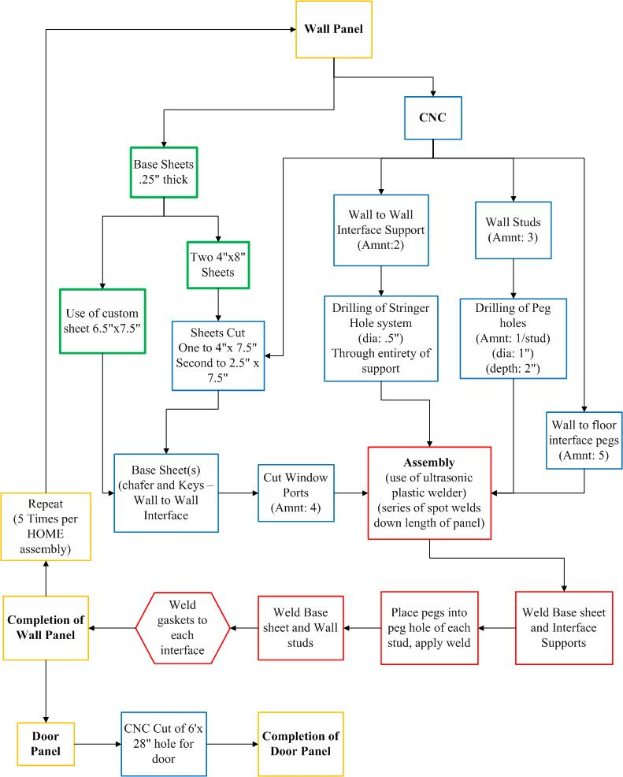

Fig 24. Half Roof Panel Manufacturing Flow Chart
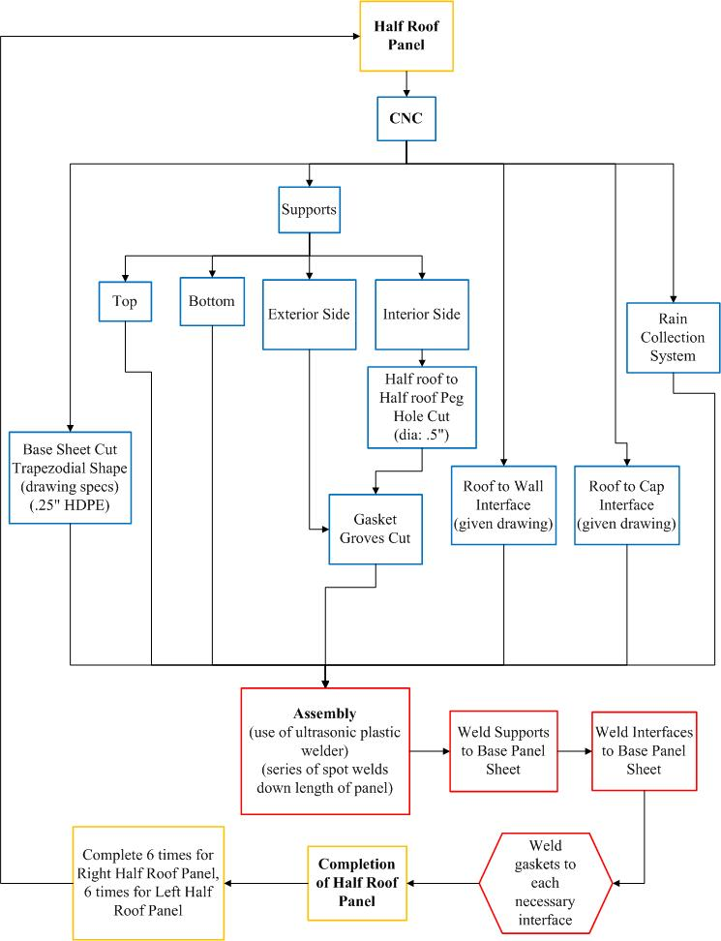

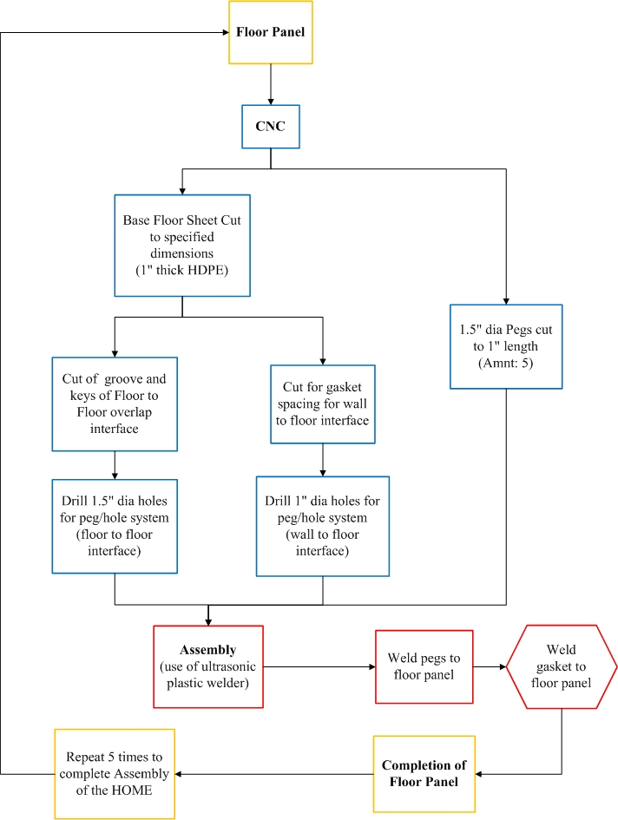
Fig 25. Floor Panel Manufacturing Flow Chart

Test | Description | Duration | Record/Verify
Interfaces | Load wall/wall interfaces | Failure | Wall interfaces took avg. load of 607lbf
Wind Tunnel | Place panels in wind tunnel to ensure roof/wall and floor/wall interfaces | 45sec | Force/stresses acting on wall
Assembly | Test subjects assembly of prototype | Individual time | Test subject figured out assembly
Testing
Table 9. Test Matrix used.
Several methods of testing were utilized to determine the adequacy of the HOME. We performed performance tests on the interfaces between the wall panels by machining samples of the same geometries of the interfaces. These samples were then affixed to the Instron testing machine and loaded until plastic deformation occurred. A test for wind resistance was performed using the wind tunnel. We made fixtures that allowed us to attach a prototyped roof panel and half model to the testing equipment. The test samples were then exposed to varying wind speeds ranging from 13.4 mph to 44.7 mph. We tested for ease of assembly by having different people try and assemble our prototype without any knowledge of the project except that it was half a hexagonal shaped house. This test was done to see what methods were common and compare them to the way we intended it to be assembled.

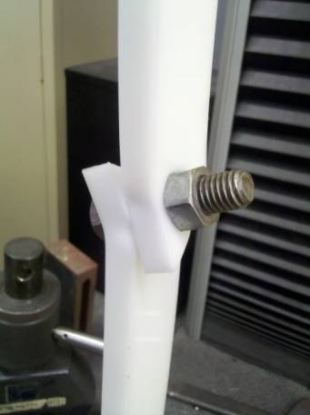
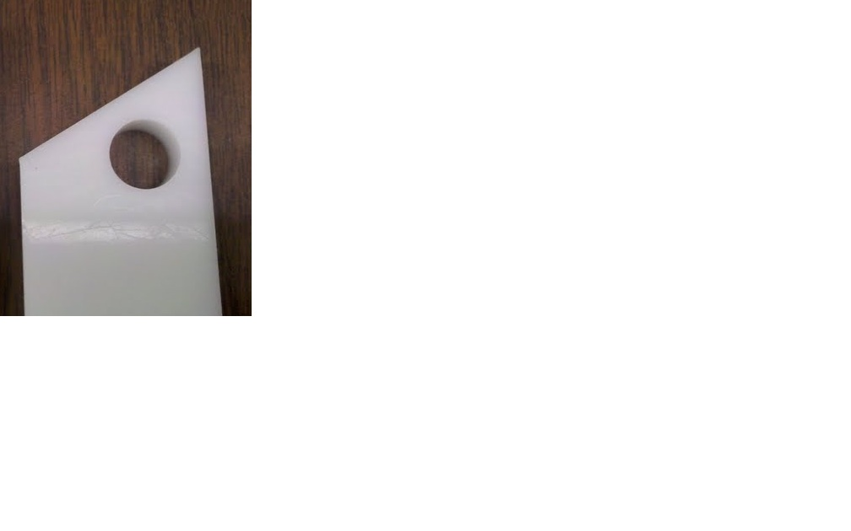
We used our sheet of HDPE that we purchased last semester to machine sample pieces of the same geometries of the wall to wall interfaces. These pieces were 9’’ long, 1- ½ ‘’ wide and ½ ‘’ thick with a 9/16th hole drilled into the side with an angle cut to the same dimensions as the walls would be. On the opposite side, a small 3/8th hole was drilled to be used to hold the samples in place during testing. Our first round of testing connected two sample pieces with a steel rod. This was done to see how much force the specimens would take in a tensile loading situation. After the steel bolt was used, we used a sample of HDPE rod that we purchased. This was an idea we had to lower the cost of materials and keep the strength needed in the interfaces. The two tests were run multiple times and the results were then compared to determine a) what amount of load the interfaces could handle and b) if the HDPE stringers could be used instead of a steel stringer. The samples were pulled apart until plastic deformation occurred which we considered as failure
Fig 27. Steel Stringer
Fig 26. Testing sample
The data retrieved from the steel string test showed us that the samples could with stand a force of over 650lbs. The samples showed deformation as can be seen in the pictures to the right. These samples are only ½’’ thick, the real wall to wall interfaces are 16’’ thick. This leads us to believe that the interfaces would be able to withstand an even greater load.

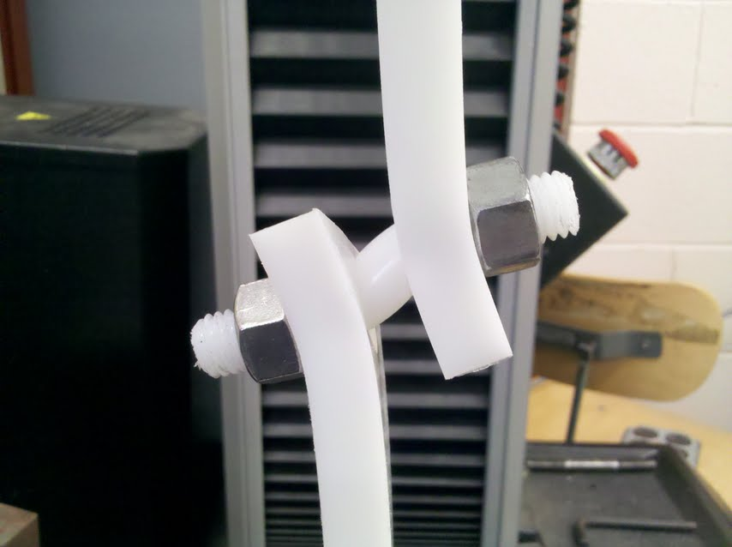
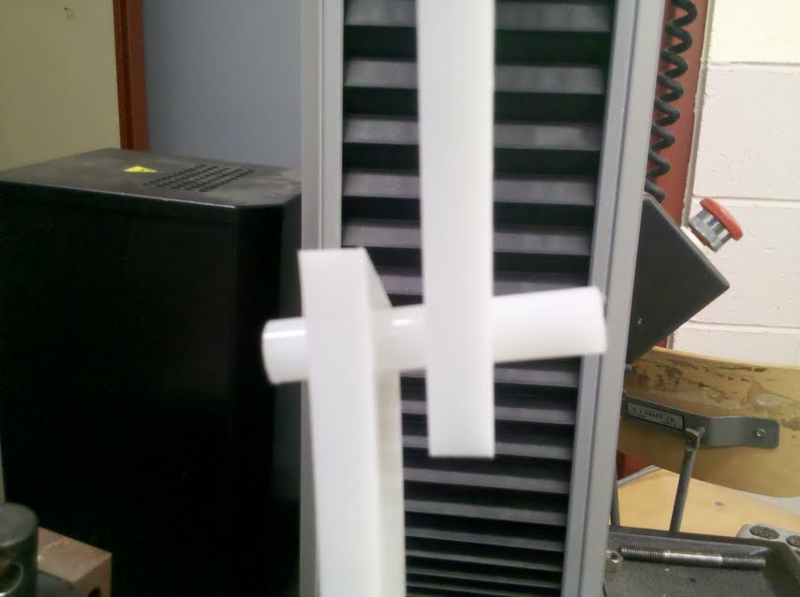
The HDPE stringer test was performed the same way. Samples were set up in the Instron machine with an HDPE rod connecting the two pieces. The first time the test was done, the sample pieces slipped apart and didn’t allow us to gather any data. We went to the machine shop and were able to thread both sides of the rod. This way we could use nuts to hold the samples on to the rod. The results gained from this test were very encouraging. The HDPE stringer was able to withstand loads of over 450lbs. This is about 200lbs less than that of the steel stringer, but is still higher than the walls are going to be subjected to. The wall to wall interfaces are designed to be able to withstand forces that men would be able to apply to
Fig 28. HDPE rod without nuts (left), with nuts (right)
them. 450lbs is more than several men could inflict on the walls. These tests had us make the switch to the HDPE stringer and keep our wall to wall interface as designed.
Figure ##. Test results from the wall to wall interface using a Steel Stringer. It can be seen that the interface withstood forces of over 650lbs.

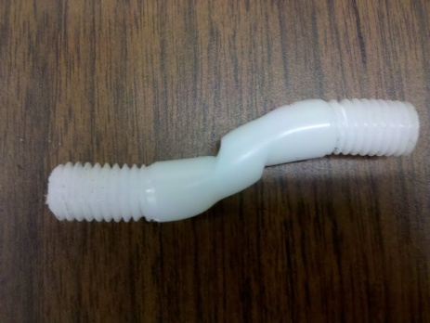
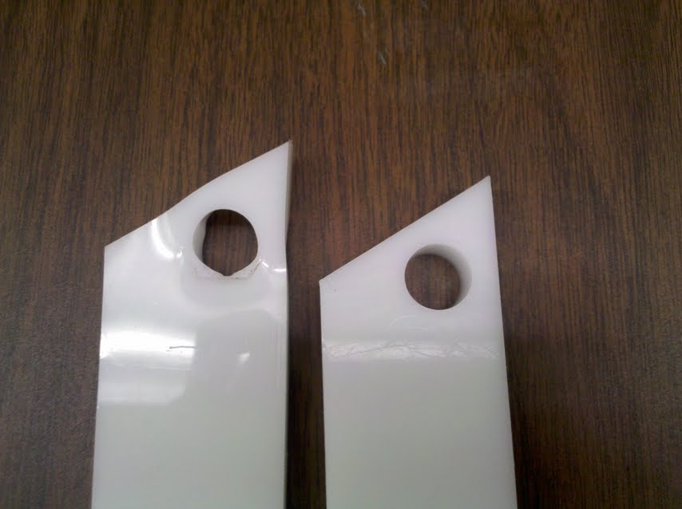
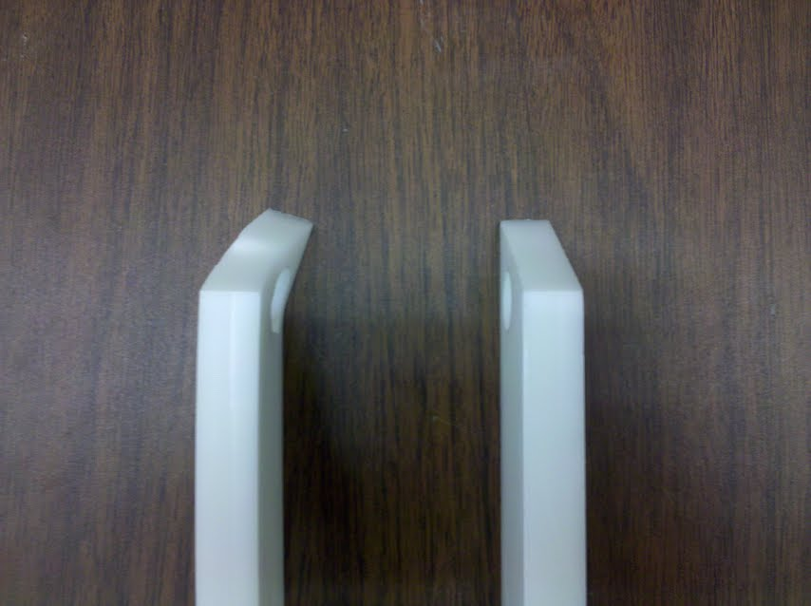
Fig 29. Deformed samples on the left compared to the non-deformed on the right (left and middle) HDPE stringer after test (right)

Fig 30. Test results from the wall to wall interface using a Steel Stringer. It can be seen that the interface withstood forces of over 650lbs.

Fig 31. Test results from the wall to wall interface using a HDPE stringer. It can be seen that the interface withstood forces of over 450lbs.

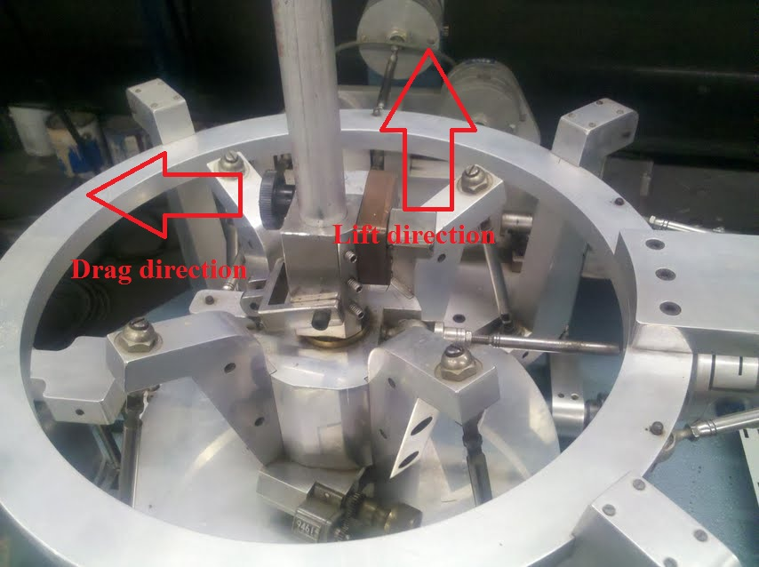
The wind tunnel tests were considerably more elaborate in their construction and data collection. The first obstacle was that the wind tunnel was missing two pieces, a Plexiglas sheet to cover the viewport opening, and an anemometer to measure the wind speed within the tunnel. Mr. Jim Byrnes was able to assist us in getting a new Plexiglas sheet and finding an Anemometer. With the new pieces we were able to move forward. The next thing that we did was calibrate the strain gauges in the wind tunnel. For this we used a digital force gauge by applying force to the rod that was attached to the strain gauges and recording the voltage readings. We were able to match the highest voltage recorded to the highest amount of force applied to see what the relationship between the two was. From the calibrations, we were able to determine that for every volt measured in drag resulted in 32.32lb of force and for every volt measured in lift resulted in 33.09lb of force.
Fig 33. The results from both the drag and lift calibrations done on the wind tunnel strain gauges.
Fig 32. Strain Gauge arrangement
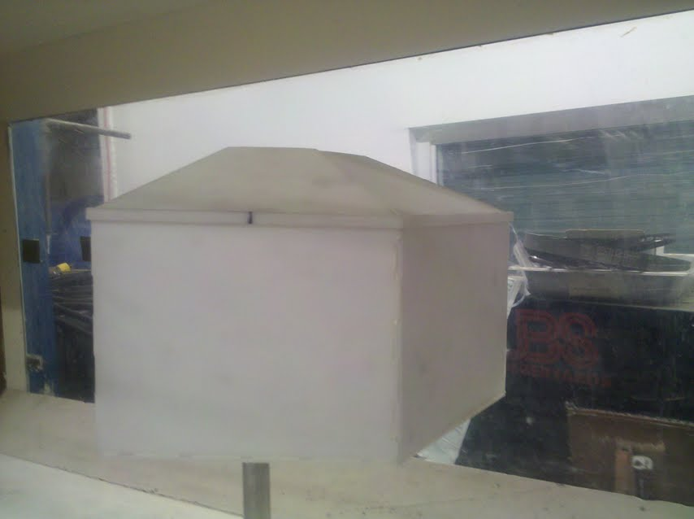
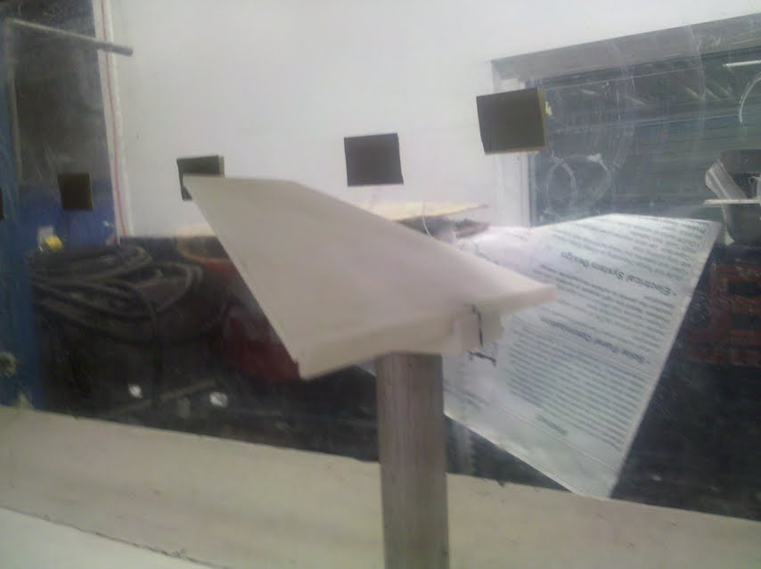
Next we began to test our prototype in the wind tunnel. The test were performed at wind speeds of 6 m/s to 18 m/s for the roof and from 10m/s to 20m/s for the half model. The roof piece was only able to be tested up to 18 m/s because at high wind speeds the piece used to hold it in place failed, causing the roof panel to disconnect and be thrown to the back of the wind tunnel. Each test ran for 45 seconds and data was collect every 0.05 seconds creating 900 data entries for each test. At first the data we collected was difficult to interpret. The results were very sporadic with many seemingly random outliers. This was due to the samples vibrating while on the testing rod. The vibrations were causing the outliers by bouncing on the rod with enough force to be picked up by the strain gauges. We added a trendlines to the results to show the average force for each test. These results were then adjusted for the calibration and for scaling from the prototype to the actual HOME for analysis.
Fig 34. Roof (left) and Half Model (right) in the Wind Tunnel
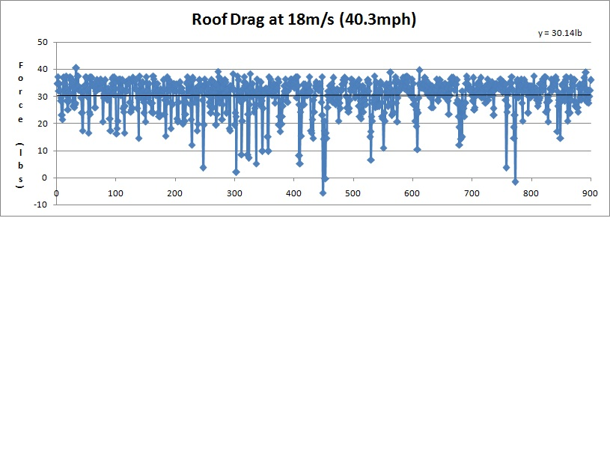
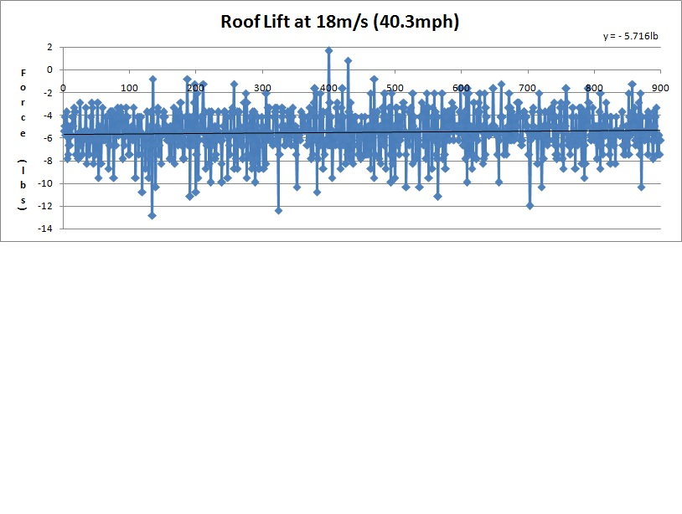
Fig 35. The drag on the roof at 18m/s (40.3 mph). The roof sees 30.14lb drag force on average.

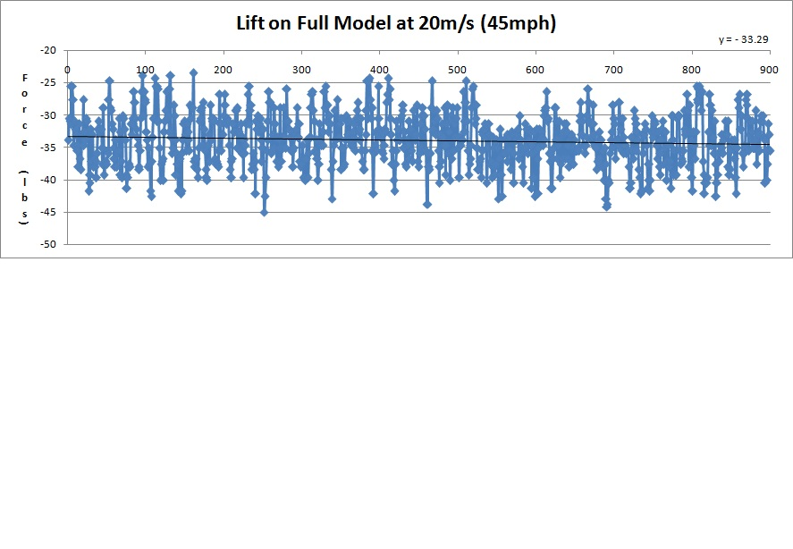
Fig 37. The lift on the half model at 20m/s (45mph). The half model sees -33.29lb lift force on average
Fig 36. The lift on the roof at 18m/s (40.3 mph). The roof sees -5.716lb lift force on average.
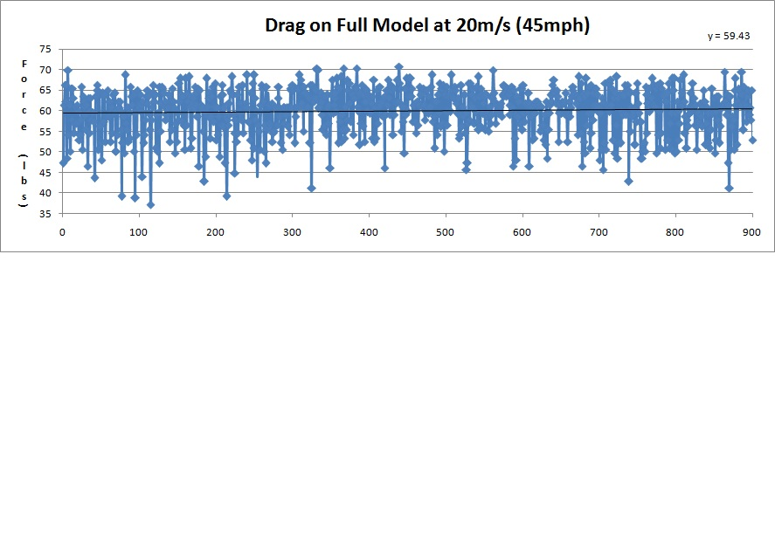
Fig 38. The drag on the half model at 20m/s (45mph). The half model sees 59.43lb drag force on average
The tests prove that our design for the HOME will be able to withstand a wind load of 45 miles per hour as stated in the SRD provided by Mr. Davids. The negative values for the lift forces indicate that the force will be pushing the structure down instead of up. This will force the structure in on itself and will have no negative affects because the roof and wall panels were design to withstand much greater loads then we derived from these tests.

The assembly test was simple. We took 10 test subjects, gave them the panels for our prototype and asked them to put it together. Five subjects were given a picture of the structure completed and 5 were not. All subjects were not told what the pieces were, although all seemed to understand that they were given three floor, three roof and three wall panels. The test was concluded when the subject had the half model complete.
Subject # | Given picture | Assembled properly | time (min) | Average time (min)
1 | yes | yes | 1:36 | 1:41
2 | yes | yes | 1:42
3 | yes | no | 1:28
4 | yes | yes | 1:54
5 | yes | yes | 1:46
6 | no | yes | 2:23 | 2:40
7 | no | no | 2:39
8 | no | no | 3:12
9 | no | yes | 2:19
10 | no | yes | 2:47
Table 10. Assembly Test Results
We found that most subjects (7 out of 10) assembled the model as we design it to be; this being the floor first, then the walls and then the roof panels. The three subjects that assembled the model the incorrect way put together the floor, a wall and then a roof panel without setting up the other wall panels. Two out of the three that assembled the model incorrectly were not given a picture of the completed model. The subjects without a picture also took a full minute longer to assemble. This test showed us that our design was easy to assemble for most people and somewhat complicated for others. This problem required that we create an assembly manual. The manual can be seen in Appendix A61-A72.

Redesign
The final design of the HOME was reached after many revisions to the original concepts generated at the beginning of the year. Our testing proved that the HOME will meet and exceed the requirements for strength and ease of assembly. Parts have been redesigned for reduction of weight without reducing structural integrity, reduction of material costs, as well as manufacturability. These included creating the stud features on the wall panels and cutting the roof panels in half.
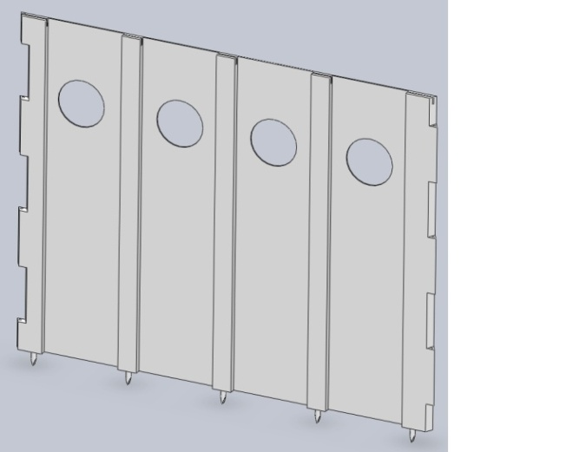
The biggest concern about our original design was the cost of the HDPE sheets and the ability to manufacture the panels. We had wall panels that were 1.5’’ thick with complicated interfaces on the sides that would connect with the other wall panels. The original plan was to have these huge wall panels molded through some manufacturing process. We had known that it would be highly unfeasible and very costly to do. Once we found the ultrasonic plastic joining technology, we were able to use multiple sheets to create one wall panel. We then had the idea of using a thin sheet of HDPE for the main component and using thick sections from another sheet cut into sections for use as studs. This lowered the weight of the walls significantly from 312lbs to 125lbs. With the studs in place, the wall interfaces are still able to take a force of 600lbs before significantly deforming. This new design also lowered the cost of each wall panel. The original 1- ½ ’’ thick sheets of HDPE are $739.58 each while the ¼’’ sheets cost $114.23 and the 1- ¼’’ sheets cost $336.64.
Fig 39. Final Wall Panel
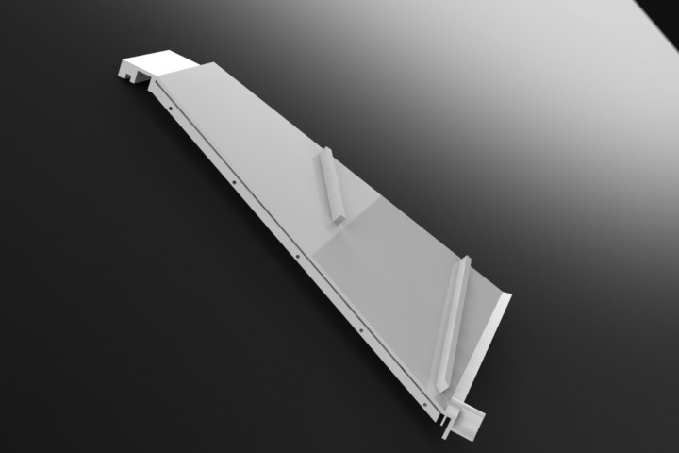
The roof panels have been through several design revisions. The original design was to have six roof panels that would be interfaced with the six wall panels. These roof panels were going to be almost has heavy as the original wall panels weighing around 250lbs. After the discovery of the ultrasonic plastic joining, the roof panels were redesigned to be made out of thinner HDPE sheets with side supports to keep the strength of the panels. This reduced the weight of the panels to 105lbs. This is a much more acceptable weight compared to the original but yet still too high to be easily assembled by two people. We then had the idea of cutting the roof panels into symmetrical halves. This cut the weight in half, but also added another interface which we were trying to avoid. After looking at the pros and cons of the new half roof panel design, it was decided that the lower weight was more important that having 6 additional interfaces between the roof panels. The new half roof panels weigh 52.5lbs. This is much easier to lift and maneuver over a person’s head and makes the assembly much easier. The interface between the two half roofs is a simple pin and hole design with rubber gaskets to make the seal water tight. The water collection system also has a feature on the final roof panel design. The raised groves are there to guide the water to the center of the panel where the PVC piping system brings the water to the collection tanks.
Fig 40. Final Right Roof Panel
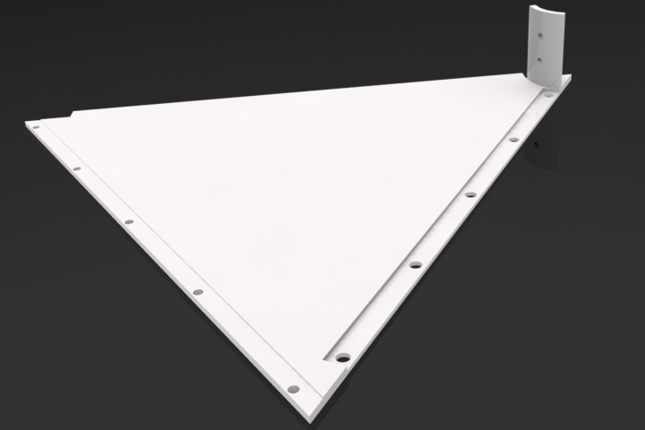
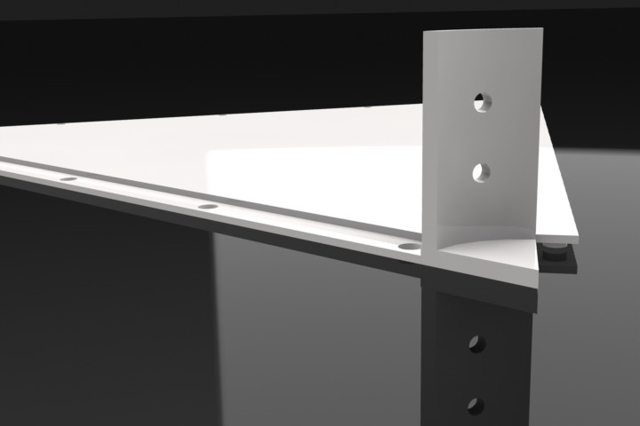
The floor panels were also redesigned multiple times. The original interface between the floor panels was a simple over lapping section that was secured by snapping into place. This design was quickly thrown out because of tolerance issues in manufacturing and it provided no additional securing force to the ground. The next redesign changed the interfaces to a pin and hole design. This added strength between the floor to floor connection and provided a securing force to the ground. The final redesign came from needing a new column to floor interface. The original idea was to have a compression ring or something to that affect to secure the column in the center of the floor panels. When the RWU tested the hand crank power generator, they found that the force needed to operate the crank was much greater than they thought. They required a way to secure the column from a strong rotational force as well. This caused us to design the pin and hole with the column and floor panel interface. This latest design provides strength securing the column in the center of the floor panels and eliminates the rotational forces from the hand crank.
Fig 41. Final Floor Panel
Figure ##. Column-floor interface

Operation
Once the HOME reaches its destination, it must be assembled in order to be put into service. The order of assembly will be explained here in text, though in practice it will be given through visual cues on the individual parts. An assembly manual is included in the Appendix A61-A72 of this report that shows the process of assembly visually only as adapting localized manuals for different languages would make the product more costly. In addition to raising cost, localizing an assembly manual would be wasted time as a natural disaster may happen suddenly, as in Haiti or Japan.
The first step to assembling the HOME is to lay down the floor panels at a suitable location. The triangular panels have peg and hole connections to either side so that the next piece may fit into the previous piece. There are six panels in all to the floor and once they are in place either the column can be put in place at the center of them or some of the walls can start to be put up. The power cap fits on top of the column and once in place can be moved to its designated spot on the floor panels. To prevent the column from rotating in place, pin holes were designed into the bottom of the column.
The walls have pointed pegs that fit into the remaining holes on the floor panels’ outer edges in order to dig into soft ground. With at least two wall panels set up, which will fit together like jigsaw puzzle pieces, an HDPE stringer will be inserted from the top through the two panels to ensure they stay together. The remaining wall panels, including the one with a door, will be attached in the same way. Before placing the final wall panel however it is recommended that the roof panels are placed inside the structure first for ease of installation. The door can be attached at this point or at the end after everything else.
The roof panels have been reduced in weight by splitting the once singular component into two. It does not matter whether the right half or left half is placed in the power cap’s tongue and groove connection first. Once it is rested in the power cap’s tongue and groove connection it can be placed on to the wall panel’s tongue and groove connection. When both halves are in place, they maintain their connection to each other via a hook that slips through the hole on the inner side between them. With all the roof panels in place, the main structure is complete and all that is left is the water storage tank which can be placed at any wall that does not have the door in it to collect rain runoff on the outside of the structure.

Maintenance
The HOME is made out of HDPE a very reliable plastic. The walls, roof, and floor panels of the HOME are made from this material. Having a high tensile strength and having the ability to withstand high and low temperatures, makes the material strong and useable in many environments. HDPE doesn’t shatter or splinter; it will deform under loads over 600lbs. If panels are exposed to such loads and deform to a point where they don’t perform as designed, they would need to be replaced. Replacement panels can be shipped with the original shipment of HOME units. All of the wall, floor and roof panels are interchangeable with like panels. This allows for less manufacturing lines and less confusion in assembly.
After a deployment, the HOME units would be disassembled and brought back to the storage facility. Once there, any maintenance would be undertaken. The Fixing warped panels if they were indeed fixable would occur. If the panels were deformed beyond repair, the panels can be recycled and reused to manufacture new panels. Any stringers would most likely need to be replaced as they are piece under the most stress during the time in the field from holding the wall panels in place. The rubber sealing gaskets would also need to be replaced between deployments.
The power generation and water collection system would also require maintenance. The solar panels are the most fragile component of the HOME. They are on the top and outside of the protection of the HOME. They could easily be damaged by debris or animalistic interference. The rechargeable battery and hand crank would also require replacing or cleaning. There are gears and wires that can be contaminated and corroded would need clean or replacing as well. The water collection system would need to be cleaned while in service and in storage.
We designed the HOME so that little maintenance would be needed while deployed. This makes it easier for people to live it in and not have to worry about their shelters falling apart around them. A safe and secure feeling is one of the most important things to IDPs. Being able to go to sleep and not have to worry if the ceiling will collapse on you is a luxury that we take for granted; but means everything to IDPs. The most maintenance that needs to be done in the field is simple cleaning. HDPE can be wiped down with any cloth or rag. If any cleaning products are available, they can also be used because of the chemical properties of the material. HDPE is commonly used in cutting boards and kitchen counters, meaning that it is even safe to eat off of.

Additional Considerations
Economic Impact:
The HOME requires a decent amount of startup capital to manufacture. Space, machines to use and people to run them for manufacturing are just the start. Once the units are produced, they must then be stored until they are needed somewhere around the globe. A forklift would be required to move multiple panels from the end of the manufacturing line to the packaging area and then to the storage area of the warehouse. Delivering the units would cost money as well.
A suitable warehouse would be around 15,000 square feet. This would allow for enough room to manufacture, package and store the units. Most of the space would be allocated to the storage. For manufacturing you would need CNC and milling machines to create the interfaces of the panels. The interfaces could then be attached to the HDPE sheets using the ultrasonic plastic joining technique. This process would go faster if more ultrasonic plastic joiners were purchased. All of these processes could be automated, this would increase the cost to begin manufacturing, but lower the annual cost of labor.
If these processes were not automated, many jobs would open up for machinists in the area of the warehouse. Operation of the CNC and milling machines requires one machinist each. The plastic joining would require one worker for every ultrasonic plastic joiner that is running. Other jobs that would be created include plant managers, secretaries, quality inspectors, forklift operators, and pack personnel for the units. By creating these jobs, the company would have a positive impact on the local economy for the area of the warehouse. Shipping the units would also positively affect the economy by keeping trucks, barges and airplanes busy delivering units all over the world.

Environmental Impact:
The HOME is made of High Density Polyethylene. HDPE does not breakdown or release harmful fumes. The material is commonly recycled and reused in many applications including bottles, grocery bags, milk jugs, and playground equipment. The PVC piping in the water collection system can also be recycled. It is common practice to reuse PVC pipes to reduce the amount in landfills. A process called thermal depolymerization safely and efficiently converts PVC into fuel [9]. There is also a new process being developed in Europe called Tecyloop. This process recovers the PVC plastic through dissolution and precipitation in hopes to use the recovered material as a technical nutrient [8].
While the HOME is in service, there is little impact to the environment. There are no utilities used because the HOME is completely self sustaining. The solar panels on the roof and the hand crack attached to the column provide the power for the lighting inside. This was a design requirement from the very beginning of design. The HDPE doesn’t produce any harmful fumes or decompose so it won’t leave and trace it was there once removed. HDPE is also used in many different environments without any consequence. It is often used for playground equipment and marine applications for its strength, non-fracturing properties and thermal properties. The longevity of the product also reduces the amount of manufacturing that is required which lowers emissions and the carbon footprint of the plant.
Societal Impact:
After an event, the camps and deployment areas become a new community. Camps can have anywhere from a couple hundred to several thousand people in them, all without the basic necessities of life. The HOME provides them with a place to live and begin to rebuild. The new communities would be very crowded and tightly packed. This environment can become hostile with some many people in one space. If supplies such as food and water become scarce, tempers can become shorter and cause violence. We can’t control the food or water supply but we can help to reduce the need for water with the water collection system.
When people arrive at the camps they usually have nothing with them but what they can carry and sometimes not even that. When they are all given a HOME unit, they all have the same things. This equality among the inhabitants will bring about a sense of community and hopefully help everyone get along. The idea is that everyone will come together with a common goal of helping each other through the hard times away from their homes.

Political Impact:
The political impact of the HOME is vast. In the past decade there have been several large scale disasters here in the USA and around the world. Hurricane Katrina left a wake of horrific destruction throughout the southern coastal states, claiming thousands of lives, destroying thousands of homes and left over one million people without power for over a week [5]. Many people were left outside without suitable shelter for several days while National Guard and Red Cross officials worked to set up camps and shelter sites [1]. HOME units could have been on site within a day of the disaster and set up thousands of them in the following days. The HOMEs would create a stable shelter with power generation for hundreds of families left with nothing. The fast response would have removed much of the criticism by the media and survivors for the slow response of our government.
In the past year alone there have been two major natural disasters in the world. The earthquake in Haiti killed over 200,000 people and left over a million homeless. The initial quake measured a 7 on the Richter scale and had 52 aftershocks of 4.5 or higher [3]. The world governments’ and relief organizations were quick to respond and provide aid. Many people were left living in tents for weeks and sometimes months. The recent earthquake in Japan measured an 8.9 on the Richter scale, making it the fifth worst in the past hundred years [10]. The quake leveled much of the north western region of Japan. Hundreds of people were killed or missing and several thousand were left homeless.
Both of these disasters were catastrophic and left the rest of the world scrambling to help with the relief efforts. HOME units could have been flown or shipped to different locations at both disasters. The easy to assemble design would be ideal for these conditions. Large groups of people without electric power or shelter could follow the simple directions and work together to create a new living community. The world’s perspective of the USA would drastically improve with a big relief effort. Countries would begin to view us as a helping hand instead of a policing power.

Ethical Considerations
The HOME project is designed with people’s needs and safety in mind at all times. The HOME is made of strong, durable and safe HDPE. Being able to withstand over 600 lbs of force on the roof and 450 lbs on the walls, the HOME will provide a safe living environment for a family of four. One thing that we learned from talking to RIEMA Director David Smith and URI Emergency Manager Shad Ahmed was that when the people arrive at these camps they literally have nothing left. Their biggest concern isn’t for their material possessions, but for the safety and security of their families. The HOME provides them that safety plus additional features to make their occupancy as comfortable and inviting as possible. We believe that if you have the means to help someone in need, regardless of race, creed or prior convictions, you should do all you can. We are all humans and should be treated as equals.

Health, Ergonomics and Safety Considerations
The HOME is designed to be a safe and stabile place for people to live. The HDPE material they are made out of strong and will not shatter or splinter under any kind of load. This provides a structurally sound shelter that will not collapse on the occupants. HDPE is also FDA approved. In fact, one of the main applications of HDPE is cutting boards, making the HOME literally safe enough to eat of off. HDPE also will never rot or loose strength over time, eliminating the threat of the HOME deteriorating from extended service.
All aspects of the HOME were designed with ergonomics in mind. The system requirements forced us to keep human needs and capabilities in mind at all times. The wall panels have been through many design revisions to remove weight for easier handling in the field. The roof panels have been through even more because lowering the weight was an even more pressing concern because a person would be lifting them over their heads. The HOME is also big enough to comfortably sleep four 95th percentile adults. With 135sqft of floor space and over 950 cubic feet inside the HOME, there is ample space for people and their belongings.
Safety was another big concern during the designing of the HOME. For the people in the HOME units, a sense of security is very important. The interfaces and panels themselves are able to take loads over 450lbs. During testing we found that high wind speeds will actually compress the HOME instead of lifting the roof panels. This will apply force on the structure, but not enough to cause any problems. In fact the downward force will help compress the gaskets at the various interfaces become more compacted, keeping the HOME watertight.

Sustainability Considerations
The HOME is design with sustainability in mind. It has the capacity to endure a long useful life span without little too no maintenance or negative effect on the environment. The power generation is solar and human powered. Producing no waste or by products other than sore muscles from using the hand crank. The HDPE can be recycled and reused in many applications that we see every day from cutting boards to milk jugs. This conscience approach to being environmentally friendly was a big concern for us during our designing process. We spent a lot of time searching for a material that lasted a long time without some form of deteriorating that was also able to be recycled and reused. If there are any damaged panels, they can be recycled and remade into new panels. The HOME units can also be assembled and disassembled for multiple deployments for different events. This cuts down on manufacturing needs, thus reducing the emissions and energy consumption of the manufacturing plant. Additional work could be done to address the use of grow pots that could be hung from the windows. This would help create food for the occupants and reduce the need for supplying food to the camps. The electrical components, the battery, inverter and LED, will eventually wear down and need to be replaced. The battery in the HOME is rechargeable, which adds to the lifespan of the battery but would most likely be replaced between the deployments of the HOME during storage. This is when most, if not all maintenance would be performed. The batteries can be broken down into their components and the recyclable portions would be while the unrecyclable parts would be disposed of properly. LED fixtures can last up to 20 years if operating for 8 hours a day [7]. This long life span means that unless they are broken during use, the LEDs won’t need to be replaced as frequently as the battery.

Conclusion
The HOME has been designed to meet all of the specifications and requirements. We have tested the strength of our design through the Instron testing machine to be able to withstand loads over 450lbs without failure. Through Solid Works modeling and rapid prototyping, we’ve proved that the panels come together to form a complete uniform and aesthetically pleasing structure. The HOME meets all the UN guidelines and can easily fit four 95th percentile adults comfortably and with ample room. The RWU team has also designed their water collection and power subsystems to meet the requirements in the SRD [Appendix 52-A60].
In the past nine months of working, we have come to find many things about our HOME. We have found different aspects of our design that work well and ones that didn’t work as successfully. These designs that were lacking in areas had to be re-designed, sometimes causing us to have to re-design many other portions of the HOME that were affected by these changes. For example, the original way that the walls were going to interlock was similar to the way that children’s outdoor play sets are put together by a “ball and socket” joint. This was chosen because it added no new parts and was simple to assemble. Once we were started to manufacture our first prototype, we realized two key problems to the design. First, we found out that it would be very difficult to machine the wall panels to have a ball and socket on the scale that we were making the prototype. Second, we found through testing that the ball and socket joint would not be able to withstand the desired horizontal force that could be experienced by the panels. We abandoned the design and decided that it would be beneficial to add a stringer to attach the panels together. The stringer is a HDPE rod that runs through pin holes in the key system of wall to wall interface along the sides of the wall panel. The stringers add extra vertical support and are able to achieve the horizontal load requirements desired. We also found out ways to reduce material from the panel designs. This was done by removing excess material and using a stud system to maintain structural support. Not only did this remove weight but cost of materials as well.
The HOME has the potential to be a product used worldwide. It has vast appeal to relief and support organizations looking to provide a safe, reliable and advanced shelter. The HOME has the appeal of only having to be purchased once. After a unit is made, it can be used in multiple deployments, provided that the unit isn’t significantly damaged. There is also the potential to use HOME units on trails and wildlife parks as a place to stop, charge your cell phone with the electricity generated from the power cap, get some water from the rain collection system or as its most basic use, shelter from the elements. HOME units could also potentially be modified to be used as possible shed. The power generated could be used to charge wireless tools’ batteries and the planters hanging from the windows can be as an addition to a garden. There are many potential uses for the HOME and the modifications that can be made to it, which will open up our customer base and increases the potential for commercialization. Different models of the HOME could be made to tailor them to specific environments. For example, if the HOME were to be deployed in a colder climate, an electrical heater could be worked into the power system or maybe a small stove. Also insulation could be placed in between stud areas, as well on the roof panel to help better insulate the HOME. HDPE is also available in a wide variety of colors. HOME units could be made out of culturally friendly colors for areas of the world where color has more meaning.
There are many steps forward to be made. Further work into the manufacturability and packaging of the HOME could be done to better improve those areas. A prototype or model of the power and water collection system would be useful to help gain an understanding of how each system works. A wiring diagram or layout of the electrical components in the column would also be helpful. More work into cost reduction by perhaps redesigning the floor or combining materials in the panels. Meaning that HDPE sheets could be used for the thin, main section of the panels, but use a different, cheaper material for the studs. Another factor for the HOME being completed would be finding some capital to start up manufacturing. A company already with manufacturing capabilities could possibly be found. That way, start up costs of purchasing the space and equipment to manufacture the units would be reduced or completely eliminated. In all, this project can be considered a success because it met all the standards and specifications set by the sponsor back in 2010, in which we have generated a great viable conceptual design that with some work could see itself on the marketplace in a few years.

References
- By. "Why Disasters Are Getting Worse - TIME." Breaking News, Analysis,
Politics, Blogs, News Photos, Video, Tech Reviews - TIME.com. Web. 19 Dec. 2010. <http://www.time.com/time/nation/article/0,8599,1838400,00.html>.

- "Concrete Canvas." Concrete Canvas - Rapidly Deployable Infrastructure. Web.
19 Dec. 2010. <http://www.concretecanvas.co.uk/21AboutCCS1.html>.

- "Earthquake in Haiti - The Big Picture - Boston.com." Boston.com - Boston, MA
News, Breaking News, Sports, Video. 13 Jan. 2010. Web. 08 May 2011. <http://www.boston.com/bigpicture/2010/01/earthquake_in_haiti.html>.

- Experience');document.write(', By Years. "Pay Scale - Mechanical Engineer
Wages, Hourly Wage Rate." Pay Scale - Salary Comparison, Salary Survey, Search Wages. Web. 19 Dec. 2010. http://www.payscale.com/research/US/Job=Mechanical_Engineer/Hourly_Rate
- "Fast Facts: Hurricane Katrina - U.S. & World - FOXNews.com." FoxNews.com
– Breaking News | Latest News | Current News. 6 Sept. 2005. Web. 08 May 2011. <http://www.foxnews.com/story/0,2933,167306,00.html>.

- "Haiti SOFTHOUSE | Open Architecture Network." Open Architecture Network |
A Community of Designers and Builders Collaborating to Improve Living Conditions and Sustainability. Web. 19 Dec. 2010. <http://openarchitecturenetwork.org/projects/dlygad2_haitisofthouse>.

- "Philips Lumec :: A Long Lifespan I LED." Outdoor Lighting Manufacturer |
PHILIPS Lumec. Philips Lumec. Web. 10 May 2011. <http://www.lumec.com/newsletter/architect_06-08/led.htm>.

- Texyloop® : Recyclage De Textiles PVC. Web. 10 May 2011.
<http://www.texyloop.com/index.php?lang=gb>.

- Trounson, Jim. Thermal Depolymerization.org :: TDP (Energy-Crisis Solution).
31 Mar. 2004. Web. 10 May 2011. <http://www.thermaldepolymerization.org/>.

- "UNHCR - The UN Refugee Agency." UNHCR Welcome. Web. 19 Dec. 2010.
<http://www.unhcr.org/cgi-bin/texis/vtx/home>.

- Shelter Centre | the NGO Supporting the Humanitarian Community in Post-
conflict and Disaster Shelter and Housing. Web. 20 Dec. 2010. <http://www.sheltercentre.org/>.

